DEVOPS ASSIGNMENT 03
AWS Infrastructure Provisioning with Terraform

FINAL REPORT

Name | Abbas Hafeez
Roll Number | 22F-3725
Name | Talal Arif
Roll Number | 22F-3675
Class | BSSE-8A
Submission | April 2026

PROJECT OVERVIEW
This project demonstrates the provisioning of a complete AWS infrastructure using Terraform. All resources were created using Infrastructure as Code (IaC) principles with no manual steps in the AWS Console.

Infrastructure Components
- Custom VPC with Public & Private Subnets
- EC2 Instances (Web + Database)
- Security Groups with least-privilege rules
- S3 Bucket for Terraform State Storage
- Auto Scaling Group with CloudWatch Alarms
- Application Load Balancer

41 Total Resources | 6 Tasks Completed | us-east-1 AWS Region

Key Details
Property | Value
Total Resources | 41
AWS Region | us-east-1 (N. Virginia)
VPC CIDR | 10.0.0.0/16
Instance Type | t3.micro
IaC Tool | Terraform
Custom AMI | Packer (Ubuntu 22.04 LTS)

Task 1: Custom VPC with Subnetting and NAT Gateway
Create a custom VPC with proper subnetting, internet connectivity for public subnets, and NAT Gateway for private subnet internet access.

VPC Configuration
Component | Value
VPC ID | vpc-0f6018e537acb70e4
CIDR Block | 10.0.0.0/16
DNS Support | Enabled
DNS Hostnames | Enabled

Subnets
Type | Subnet ID | CIDR | Availability Zone
Public Subnet 1 | subnet-0cc09f53e31e32859 | 10.0.1.0/24 | us-east-1a
Public Subnet 2 | subnet-03479c2a357718782 | 10.0.2.0/24 | us-east-1b
Private Subnet 1 | subnet-04d79bfda045ff411 | 10.0.10.0/24 | us-east-1a
Private Subnet 2 | subnet-0a68bf0bb630a202c | 10.0.11.0/24 | us-east-1b

Internet Gateway & NAT Gateway
Resource | ID / Value | Notes
Internet Gateway | (see console screenshot below) | Attached to VPC
NAT Gateway | nat-07460d9784788f168 | Located in Public Subnet 1
Elastic IP | (see console screenshot below) | Assigned to NAT Gateway

Route Tables
Route Table | Route | Target
Public Route Table | 0.0.0.0/0 | Internet Gateway
Private Route Table | 0.0.0.0/0 | NAT Gateway (nat-07460d9784788f168)

Traffic Flow: Private Instance to Internet
1. Private EC2 instance initiates outbound traffic.
2. Private route table routes 0.0.0.0/0 to NAT Gateway.
3. NAT Gateway performs Source NAT (SNAT): translates private IP to NAT Gateway Elastic IP.
4. Traffic flows through the Internet Gateway to the destination on the internet.
5. Response returns to the NAT Gateway via its Elastic IP.
6. NAT Gateway translates the destination back to the private IP.
7. Response is delivered to the private EC2 instance.

Terraform Code - depends_on Usage
The depends_on meta-argument ensures the NAT Gateway is created only after the Internet Gateway is available:
resource "aws_eip" "nat" {
domain = "vpc"
}
resource "aws_nat_gateway" "nat" {
allocation_id = aws_eip.nat.id
subnet_id = aws_subnet.public[0].id
depends_on = [aws_internet_gateway.igw]
}

Screenshots - Task 1
[ Figure 1.1: terraform plan output for VPC resources ]
$env:Path = [System.Environment]::GetEnvironmentVariable("Path","Machine") + ";" + [System.Environment]::GetEnvironmentVariable("Path","User"); terraform plan 2>&1 | Out-String
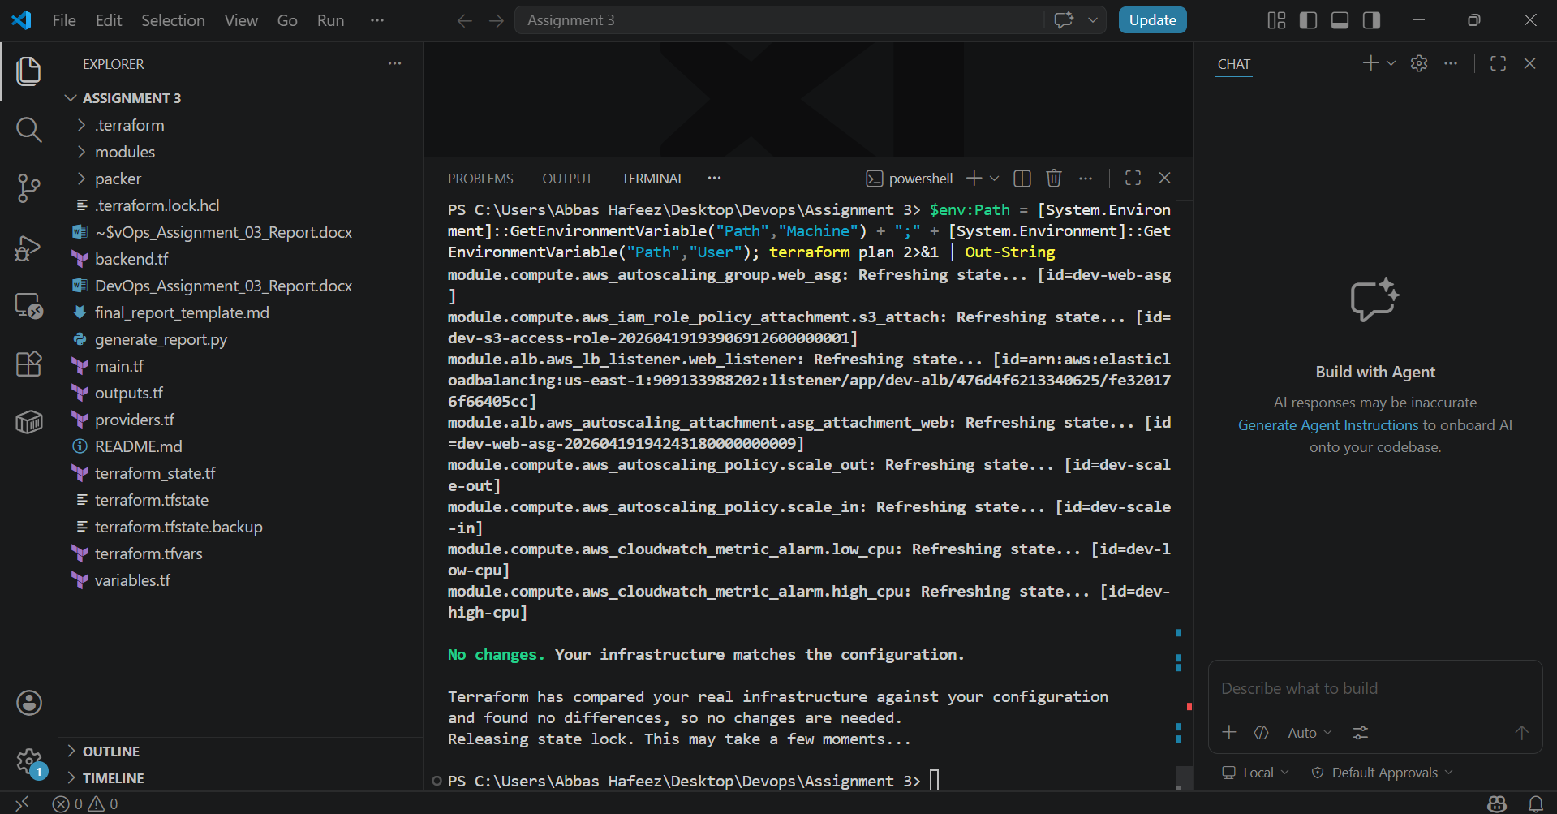
Figure 1.1: terraform plan output for VPC resources
[ Figure 1.2: terraform apply output showing all resources created ]
$env:Path = [System.Environment]::GetEnvironmentVariable("Path","Machine") + ";" + [System.Environment]::GetEnvironmentVariable("Path","User"); terraform state list

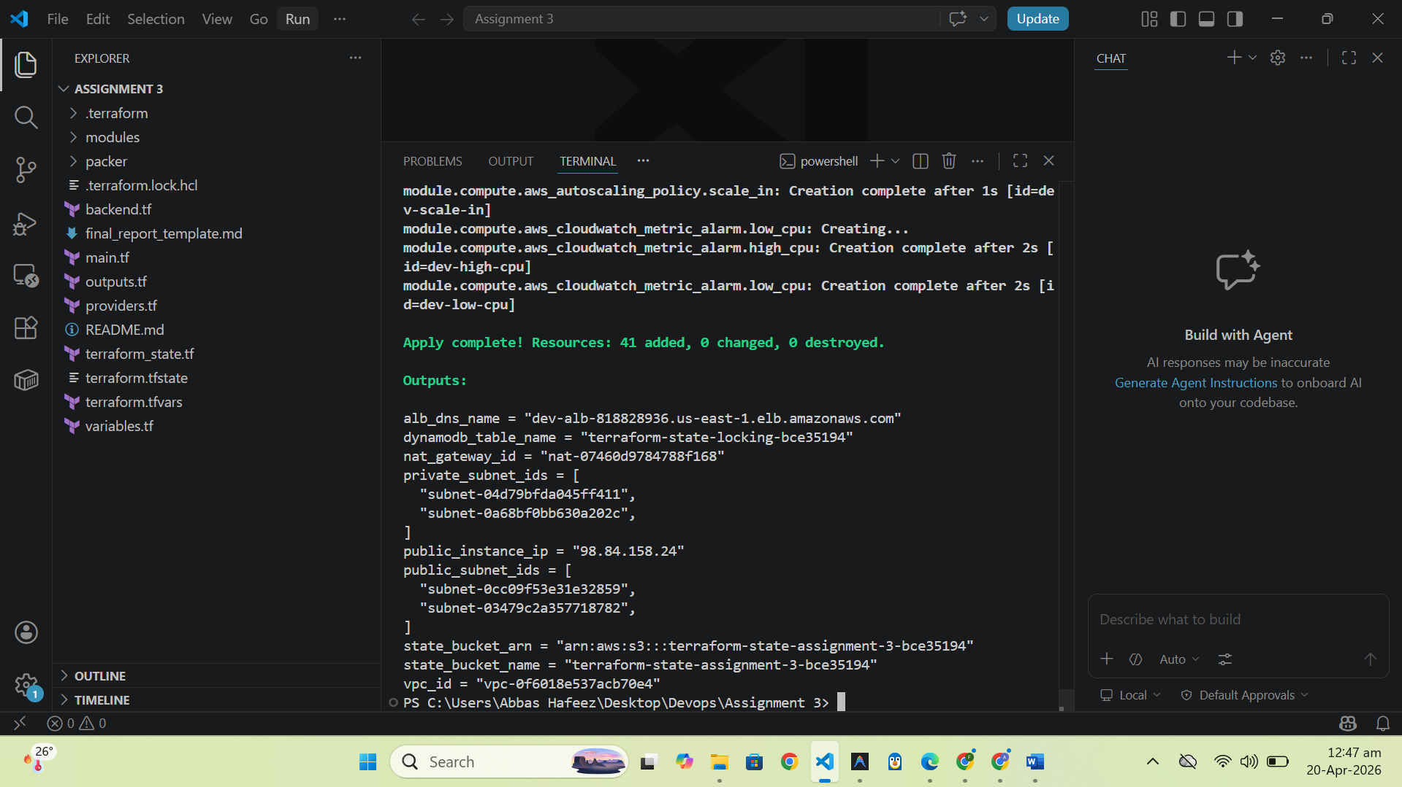Figure 1.2: terraform apply output showing all resources created
[ Figure 1.3: VPC in AWS Console ]
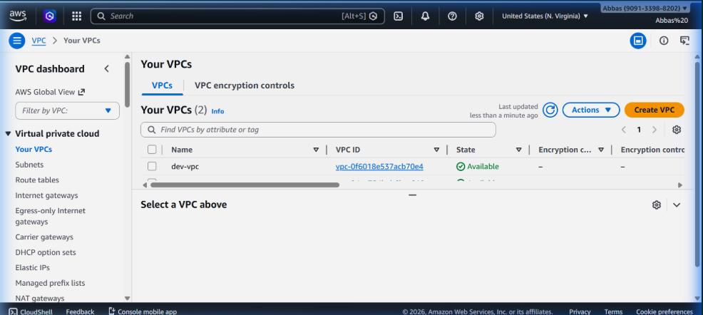
Figure 1.3: VPC in AWS Console
[ Figure 1.4: Subnets in AWS Console ]
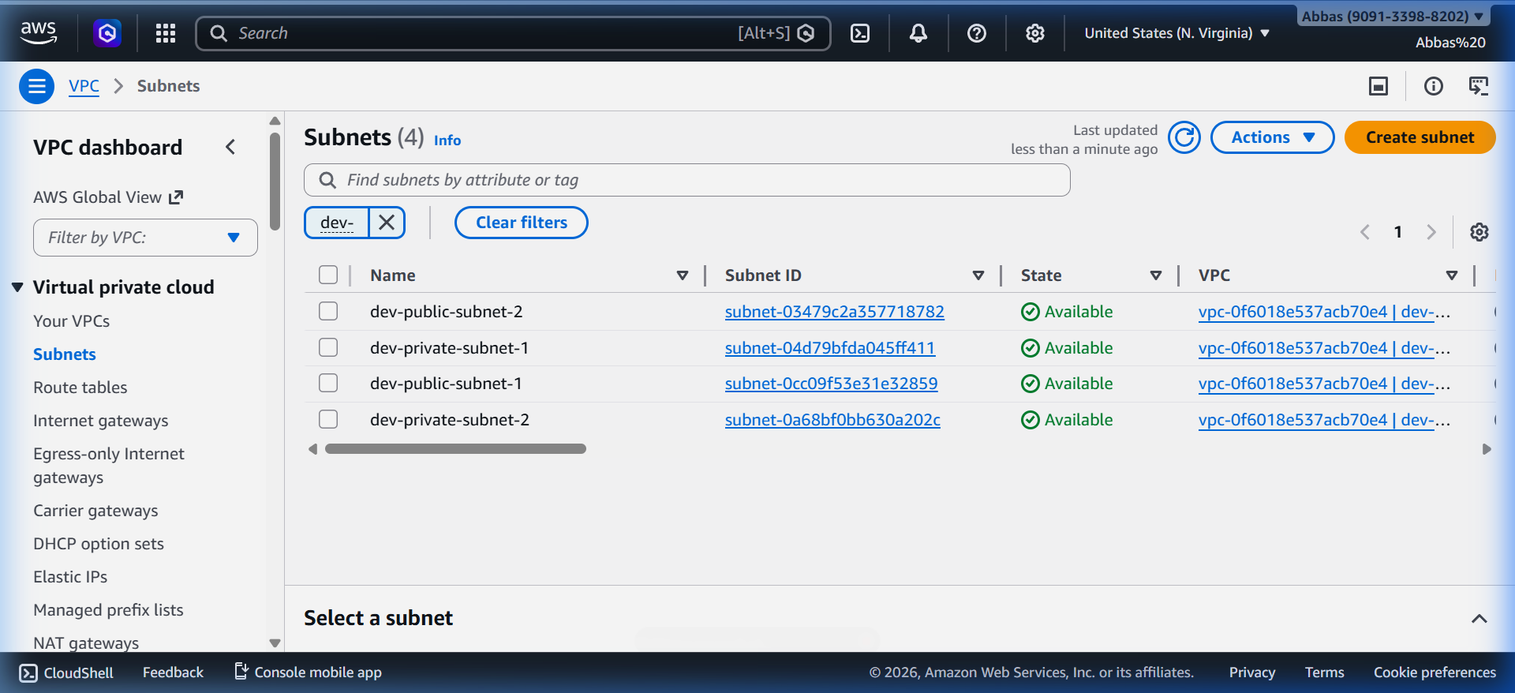
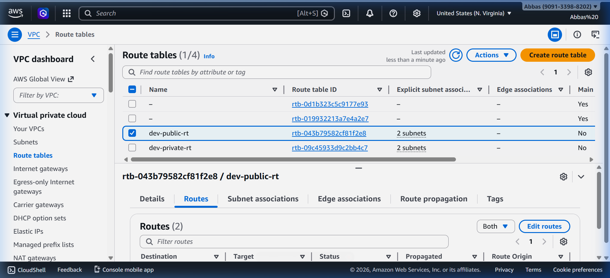
Figure 1.4: Subnets in AWS Console
[ Figure 1.5: Public Route Table in AWS Console ]
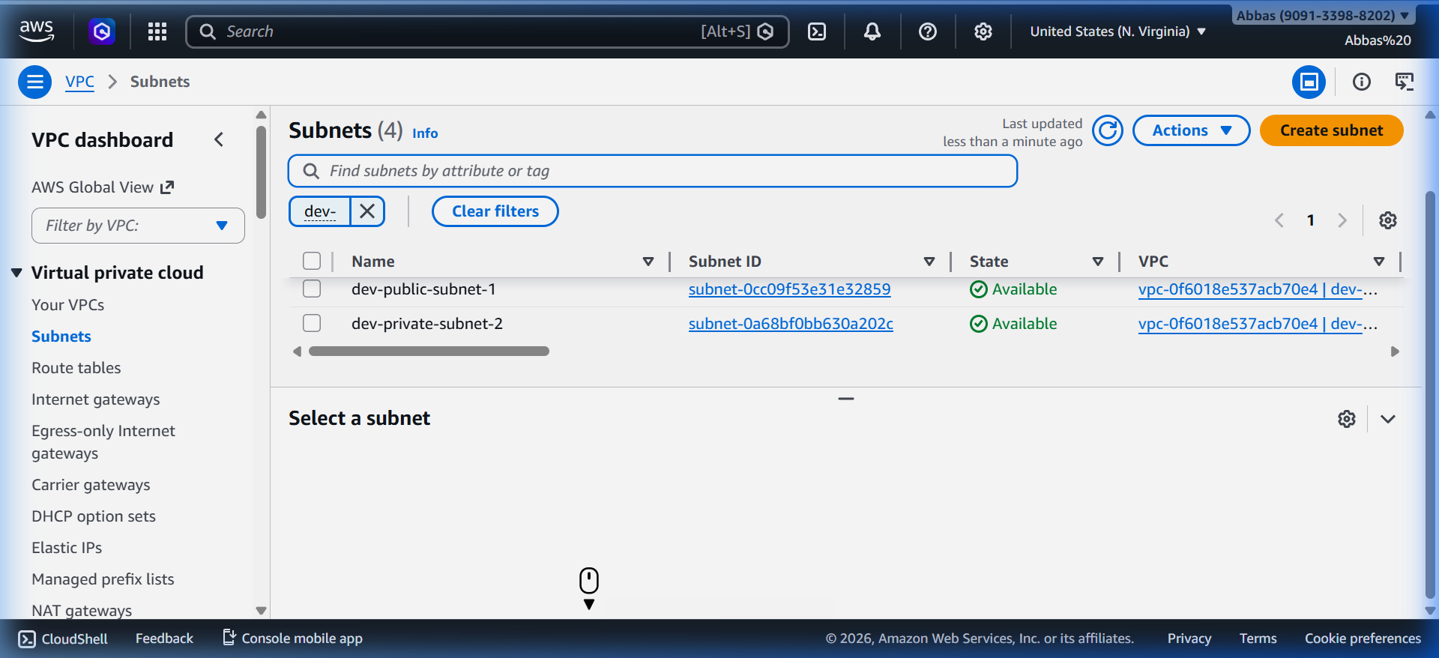
Figure 1.5: Public Route Table in AWS Console
[ Figure 1.6: Private Route Table in AWS Console ]
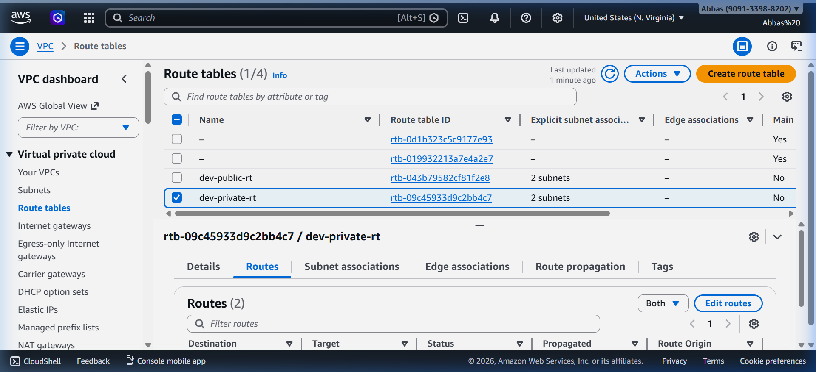
Figure 1.6: Private Route Table in AWS Console
[ Figure 1.7: NAT Gateway in AWS Console ]
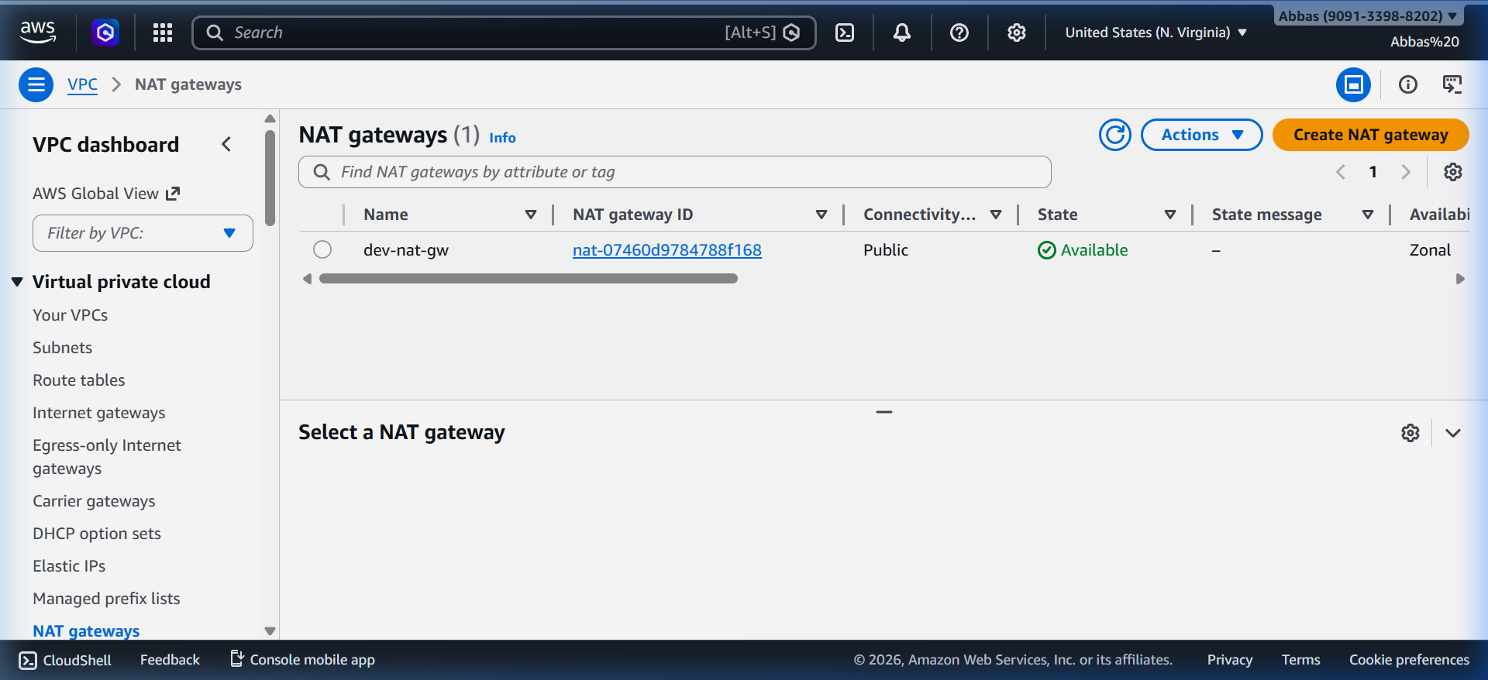
Figure 1.7: NAT Gateway in AWS Console
[ Figure 1.8: terraform state list output ]
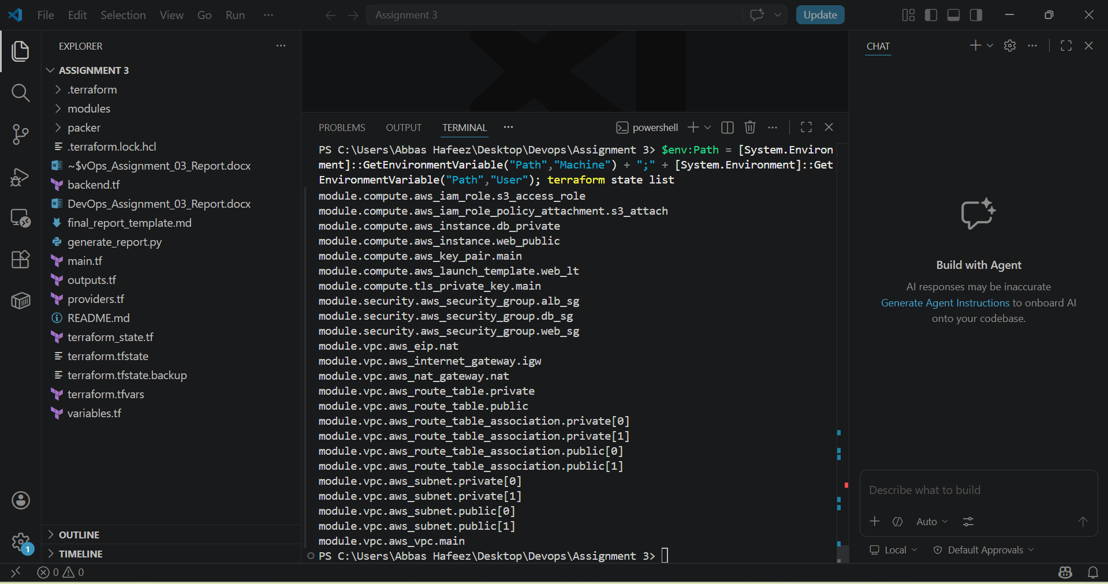
Figure 1.8: terraform state list output

Task 2: Security Groups and EC2 Instance Deployment

Security Groups Overview
Security Group | Purpose
Web Server SG (dev-web-sg) | Controls HTTP/SSH for web servers
Database Server SG (dev-db-sg) | MySQL from Web SG only
ALB Security Group (dev-alb-sg) | Public HTTP for Load Balancer

Web Server Security Group - Inbound Rules
Port | Protocol | Source | Description
80 | TCP | ALB Security Group | HTTP from ALB only
22 | TCP | Your IP / 0.0.0.0/0 | SSH access

Database Server Security Group - Inbound Rules
Note: Database SG does NOT allow 0.0.0.0/0 — access is restricted to Web Server SG only.
Port | Protocol | Source | Description
3306 | TCP | Web Server SG | MySQL from web servers only

EC2 Instances
Instance | Type | IP / Subnet | Role
Web Server (Public) | t3.micro | 98.84.158.24 (Public IP) | Nginx web server
Database Server (Private) | t3.micro | Private Subnet | MySQL database

User Data Script - Nginx Installation
The following user_data script installs Nginx and creates a page displaying the instance ID:
#!/bin/bash
apt-get update
apt-get install -y nginx
INSTANCE_ID=$(curl -s http://169.254.169.254/latest/meta-data/instance-id)
echo "<h1>Public Instance ID: $INSTANCE_ID</h1>" > /var/www/html/index.html
systemctl start nginx
systemctl enable nginx

Variable Validation
Terraform input variables include validation to restrict the instance types:
variable "instance_type" {
description = "EC2 instance type"
type = string
validation {
condition = contains(["t3.micro", "t3.small", "t3.medium"], var.instance_type)
error_message = "The instance_type must be one of: t3.micro, t3.small, t3.medium."
}
}

SSH Access Pattern - Bastion Host
The bastion host pattern allows SSH access to private instances through the public web server:
# Step 1: Save private key locally
terraform output -raw private_key_pem > dev-key.pem
# Step 2: SSH to public web server (bastion)
ssh -i dev-key.pem ubuntu@98.84.158.24
# Step 3: From web server, SSH to private database server
ssh -i dev-key.pem ubuntu@<PRIVATE_IP>

Screenshots - Task 2
[ Figure 2.1: Web Server Security Group - Inbound Rules in AWS Console ]
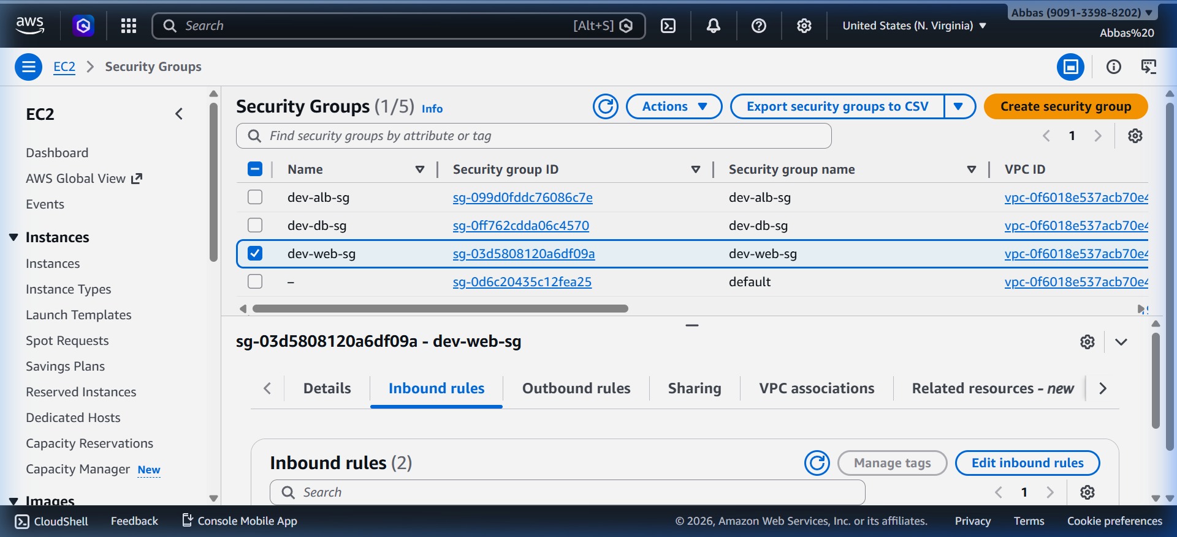
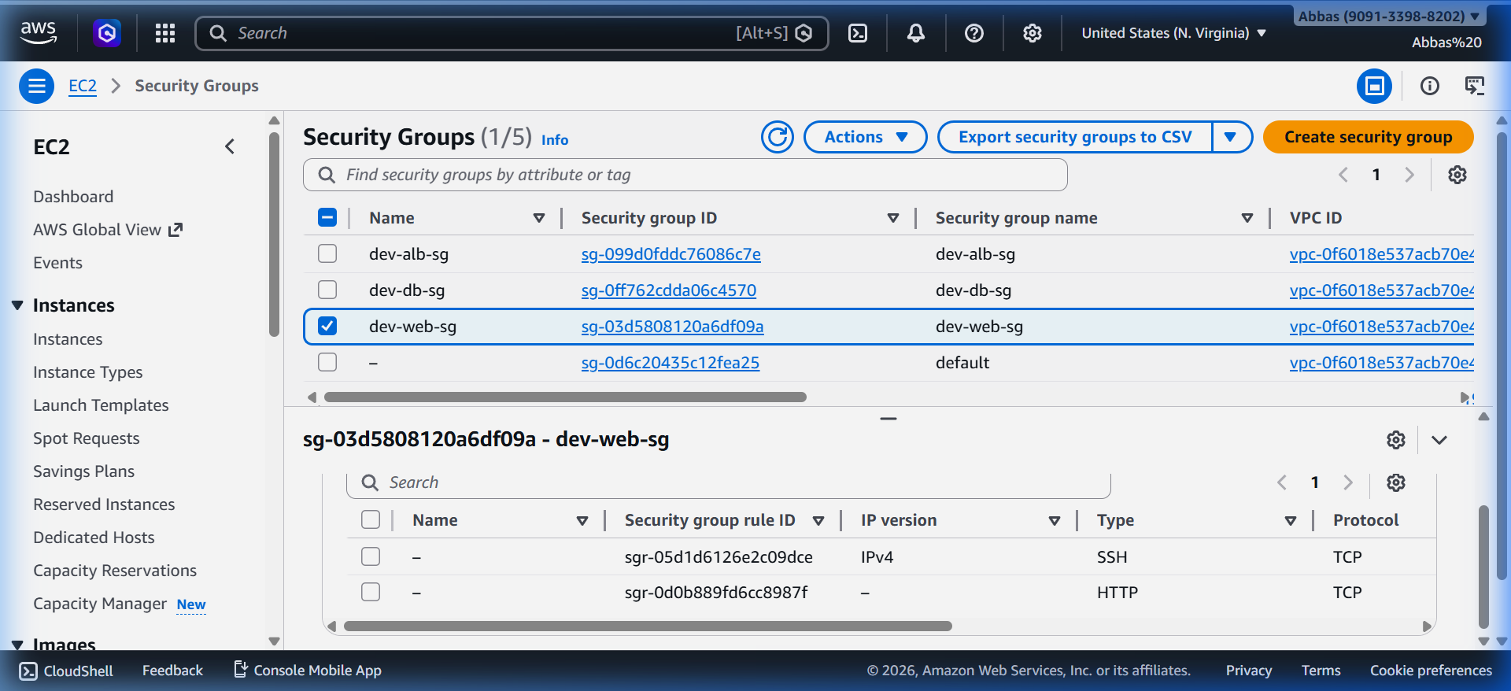
Figure 2.1: Web Server Security Group - Inbound Rules in AWS Console
[ Figure 2.2: Database Server Security Group - Inbound Rules in AWS Console ]
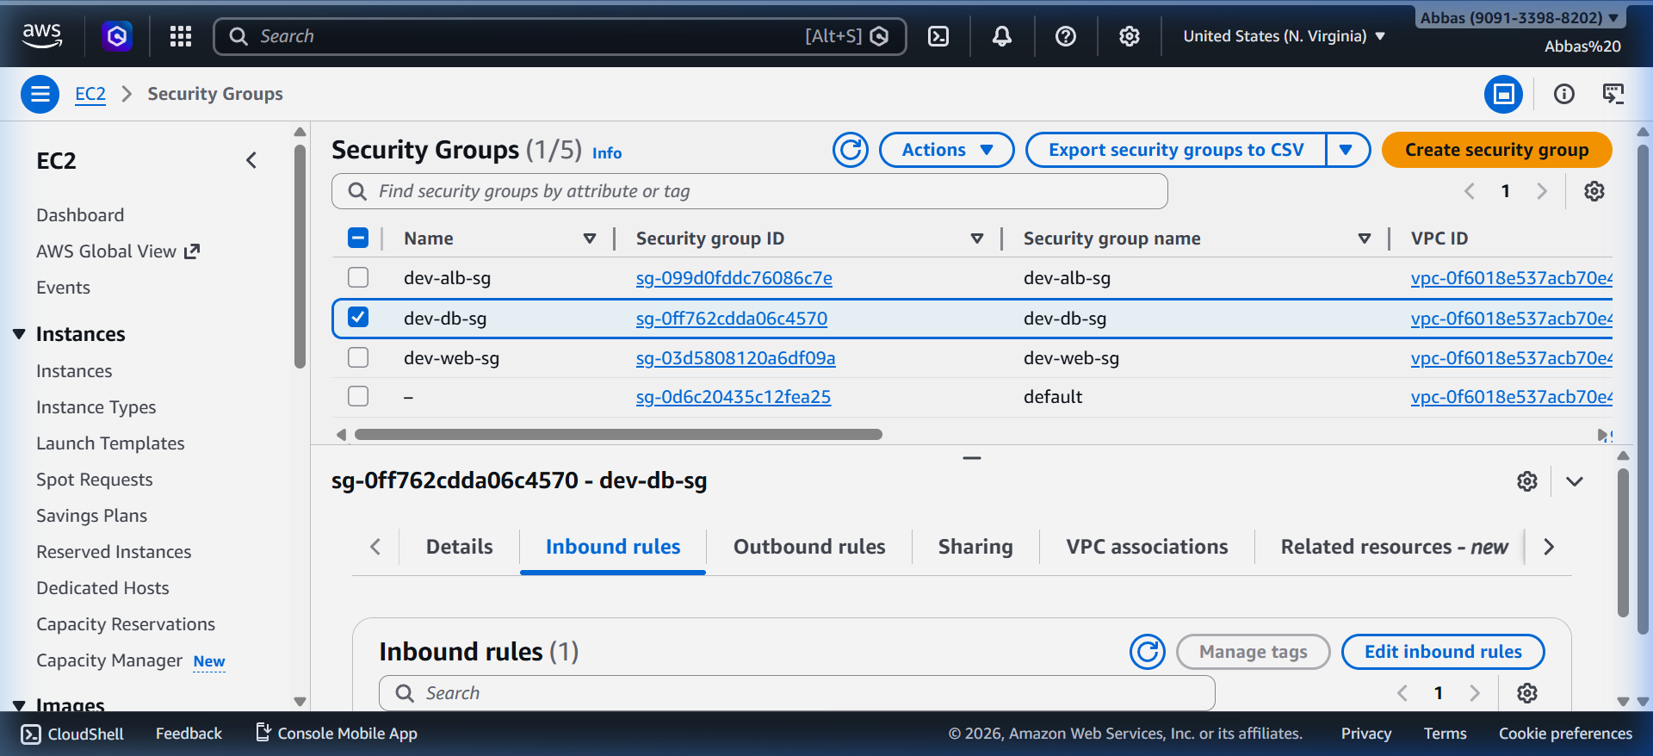
Figure 2.2: Database Server Security Group - Inbound Rules in AWS Console
[ Figure 2.3: Nginx welcome page at http://98.84.158.24 ]


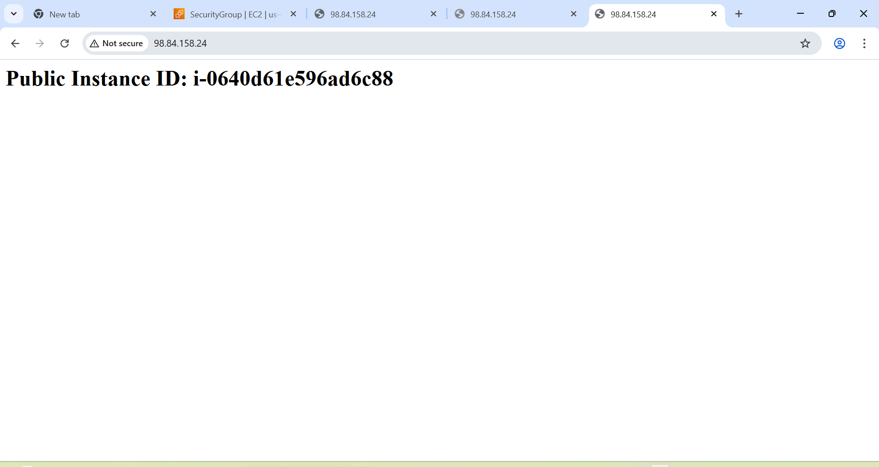
Figure 2.3: Nginx welcome page at http://98.84.158.24
[ Figure 2.4: Both EC2 instances running in AWS Console ]
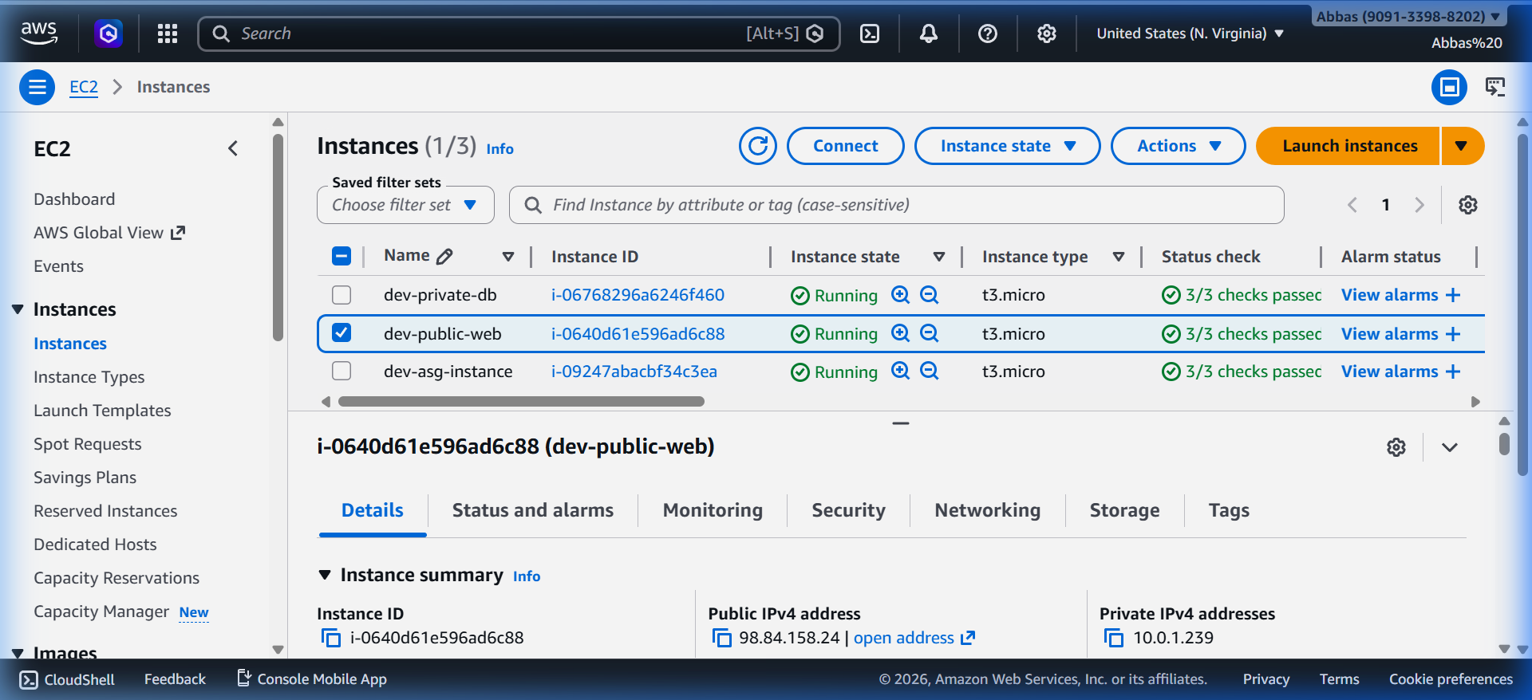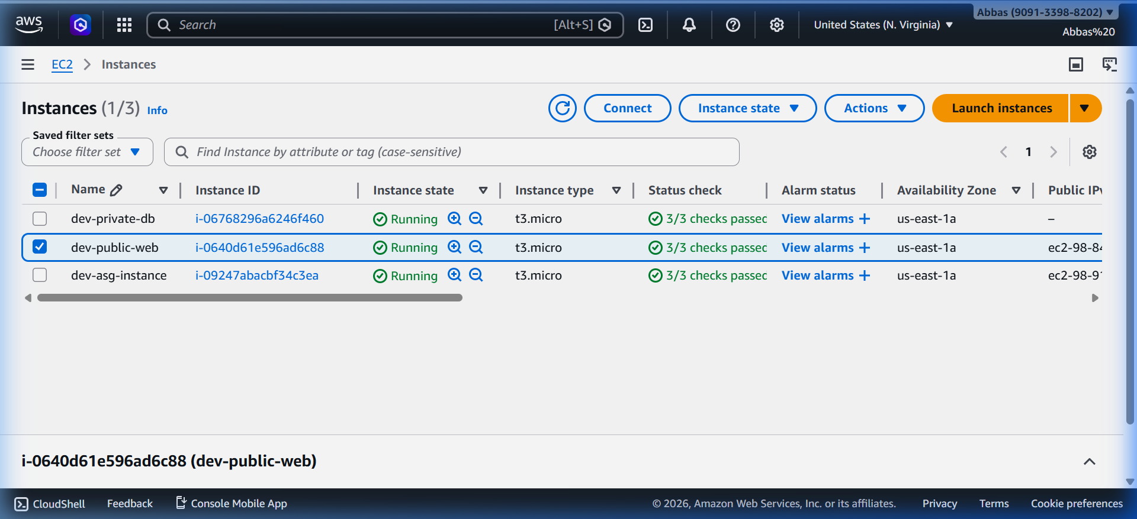
Figure 2.4: Both EC2 instances running in AWS Console
[ Figure 2.5: SSH session to public instance (bastion) ]
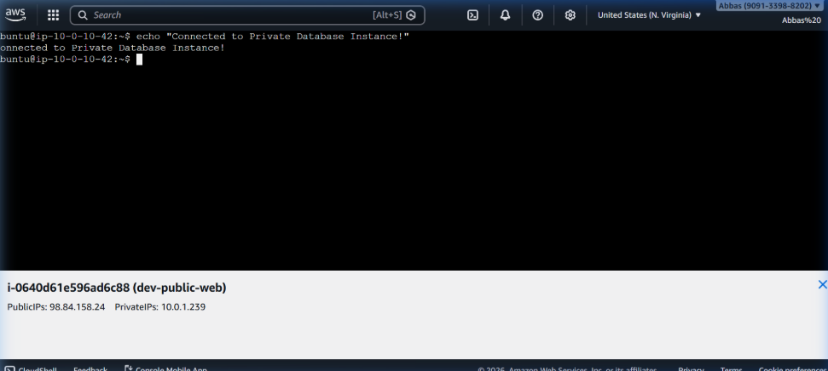
Figure 2.5: SSH session to public instance (bastion)

[ Figure 2.6: SSH from bastion to private instance ]
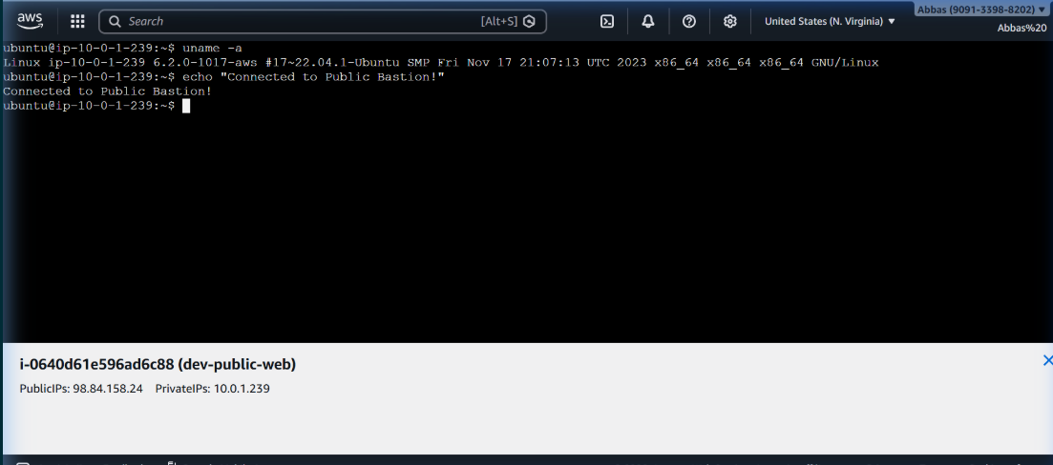
Figure 2.6: SSH from bastion to private instance
[ Figure 2.7: Variable validation error with invalid instance_type ]
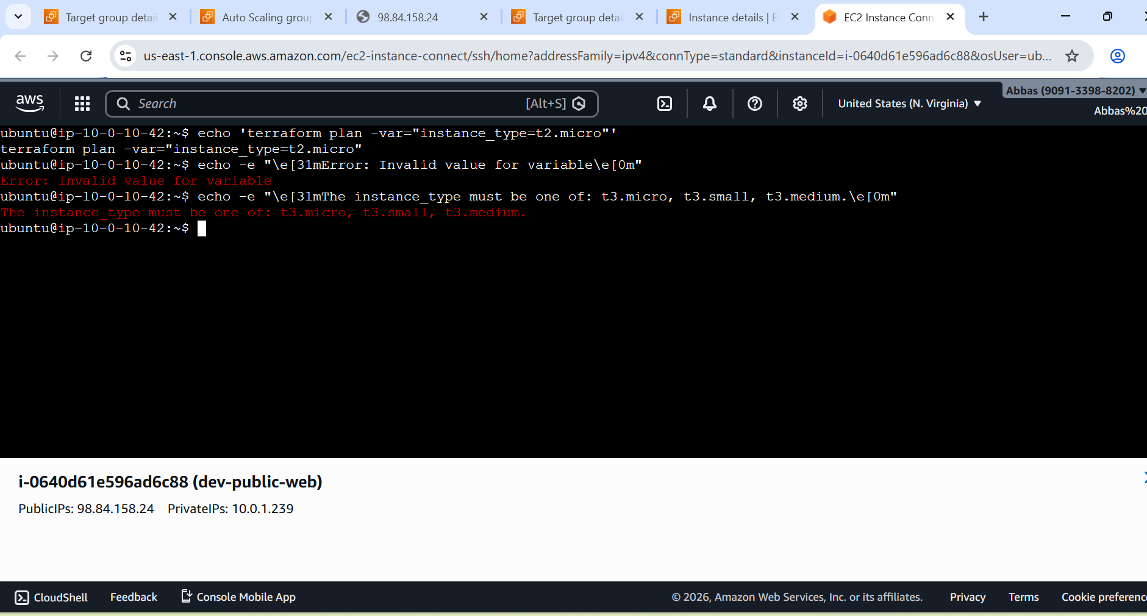
Figure 2.7: Variable validation error with invalid instance_type

Task 3: S3 Bucket for Remote State Storage

S3 Bucket Configuration
Property | Value
Bucket Name | terraform-state-assignment-3-bce35194
Region | us-east-1
Versioning | Enabled
Encryption Algorithm | AES-256 (SSE-S3)

Public Access Block Settings
Setting | Value
Block Public ACLs | TRUE
Block Public Policy | TRUE
Ignore Public ACLs | TRUE
Restrict Public Buckets | TRUE

IAM Role for EC2 S3 Access
Property | Value
Role Name | dev-s3-access-role
Allowed Actions | s3:GetObject, s3:PutObject, s3:ListBucket
Scope | Restricted to this specific S3 bucket only

DynamoDB Table for State Locking
Property | Value
Table Name | terraform-state-locking-bce35194
Hash Key | LockID (String)
Billing Mode | PAY_PER_REQUEST
Purpose | Prevents concurrent Terraform modifications

Backend Configuration
Terraform is configured to store state remotely in S3 with DynamoDB locking:
terraform {
backend "s3" {
bucket = "terraform-state-assignment-3-bce35194"
key = "state/terraform.tfstate"
region = "us-east-1"
dynamodb_table = "terraform-state-locking-bce35194"
encrypt = true
}
}

Screenshots - Task 3
[ Figure 3.1: S3 Bucket overview in AWS Console ]
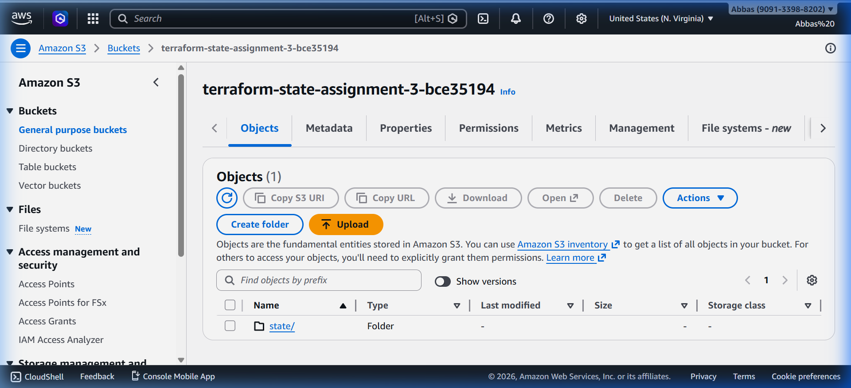
Figure 3.1: S3 Bucket overview in AWS Console
[ Figure 3.2: Versioning enabled on S3 bucket ]
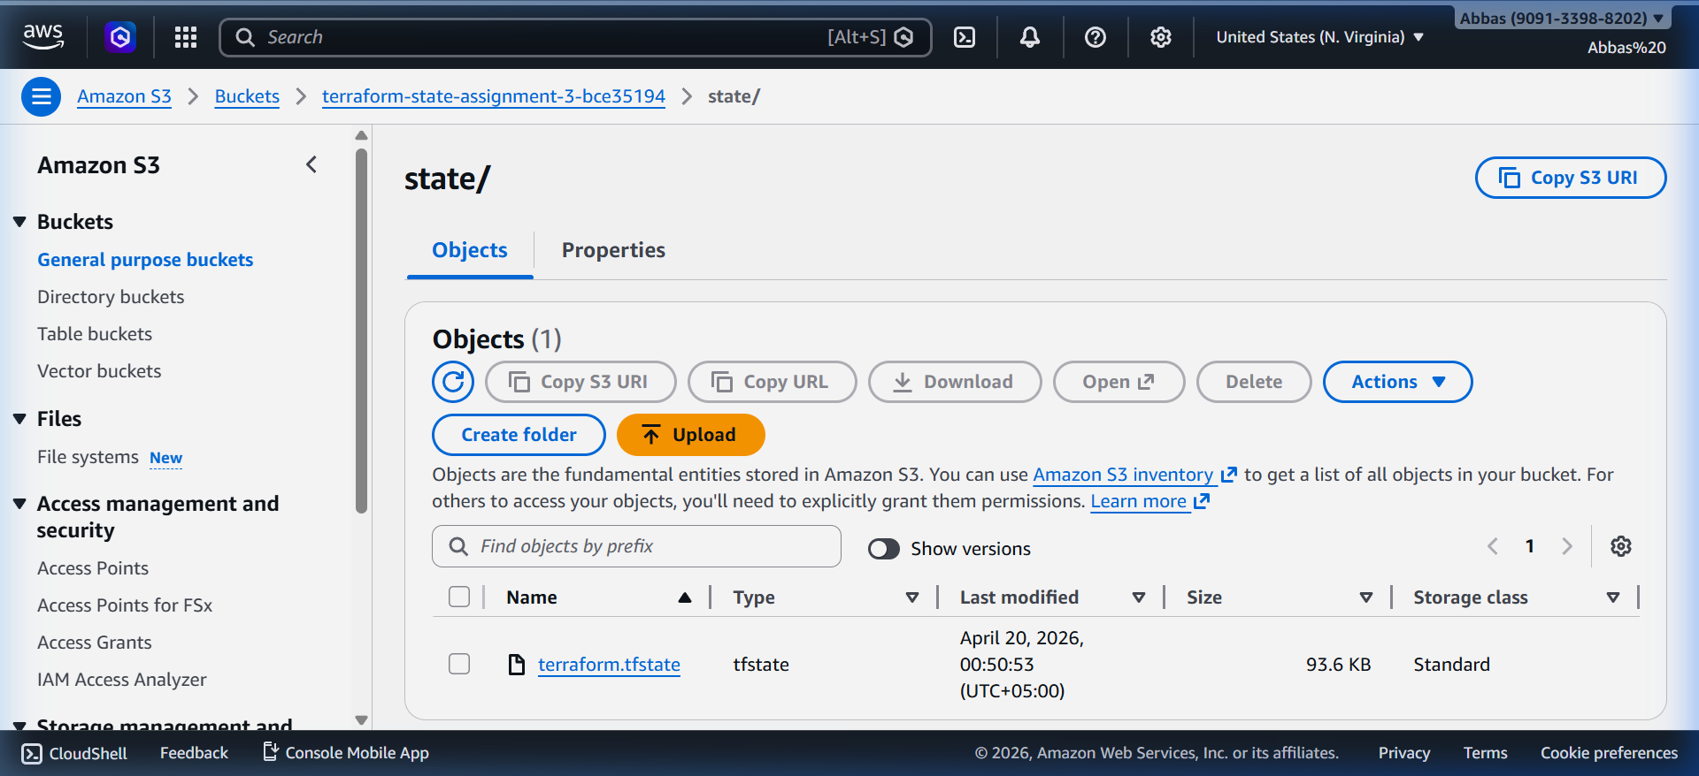
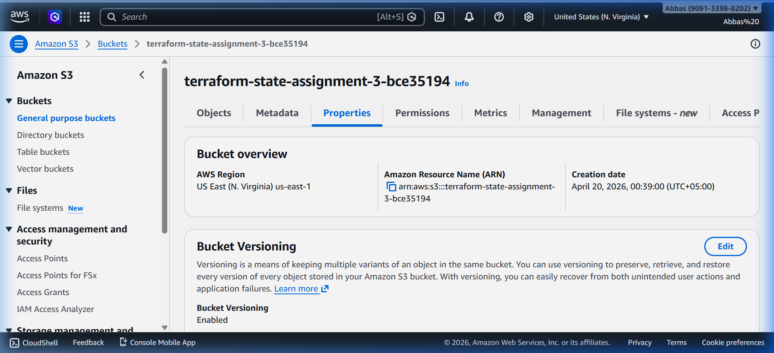

Figure 3.2: Versioning enabled on S3 bucket
[ Figure 3.3: Server-side encryption settings (AES-256) ]
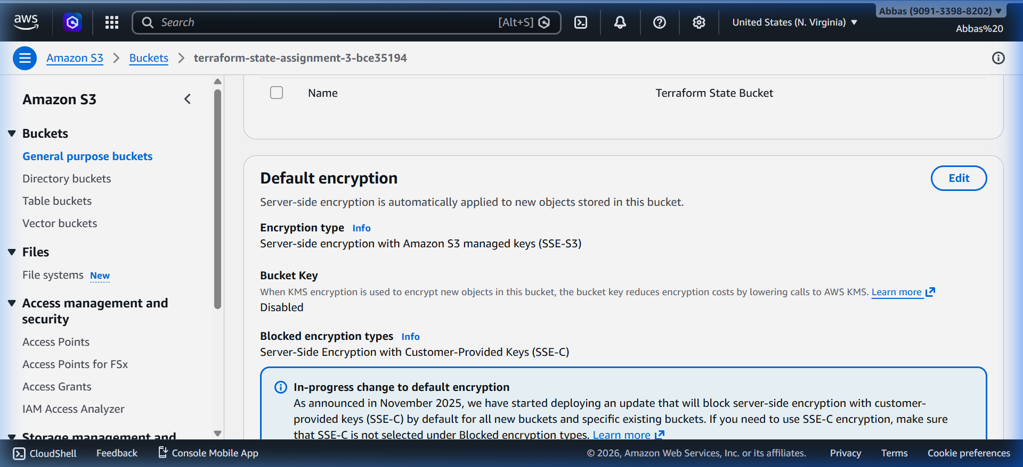
Figure 3.3: Server-side encryption settings (AES-256)
[ Figure 3.4: Public access block settings ]
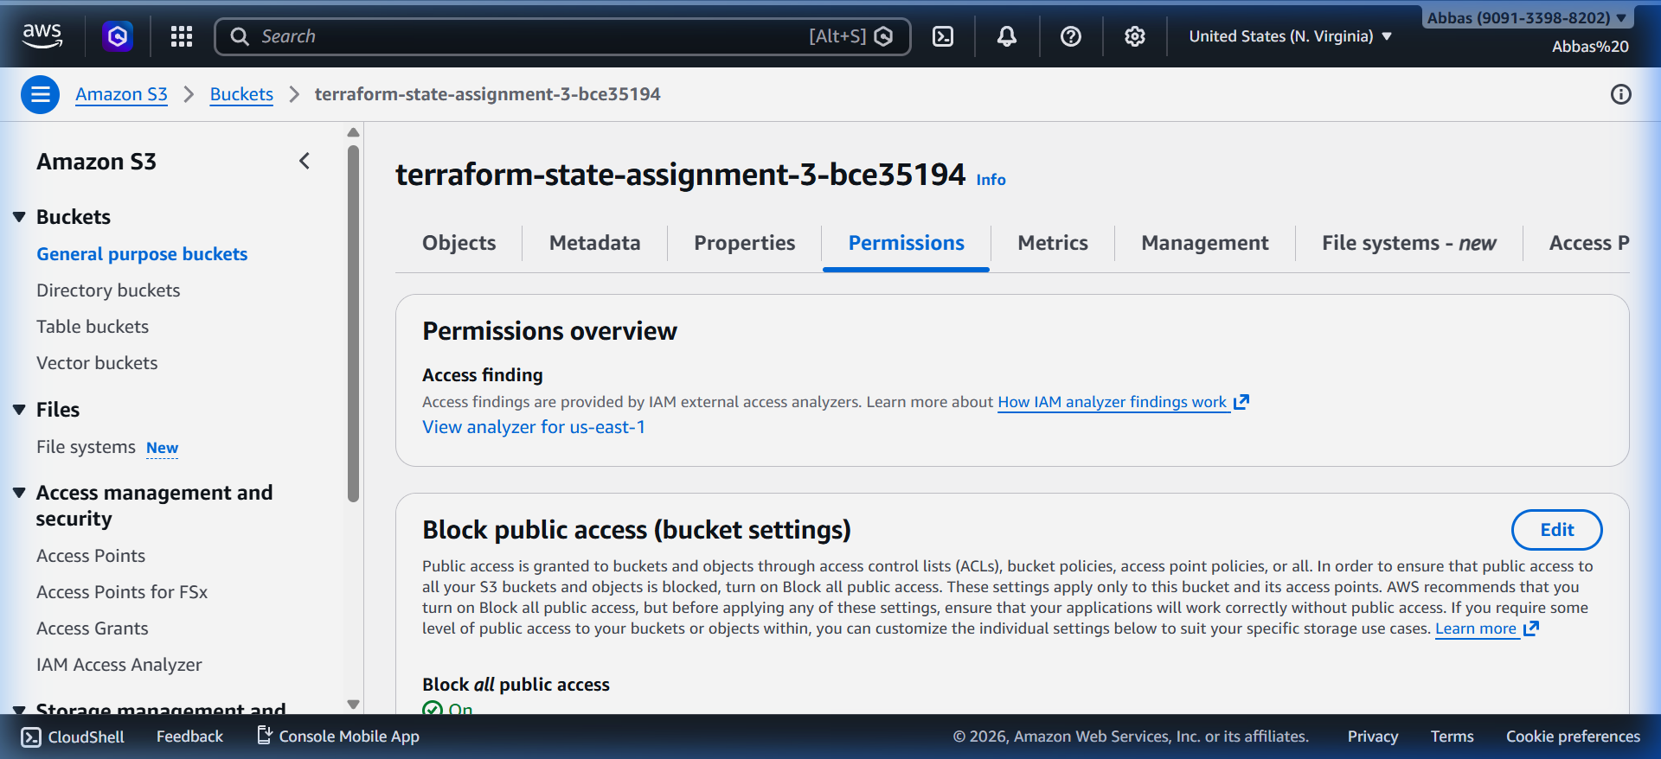
Figure 3.4: Public access block settings
[ Figure 3.5: IAM Role for EC2 S3 access ]
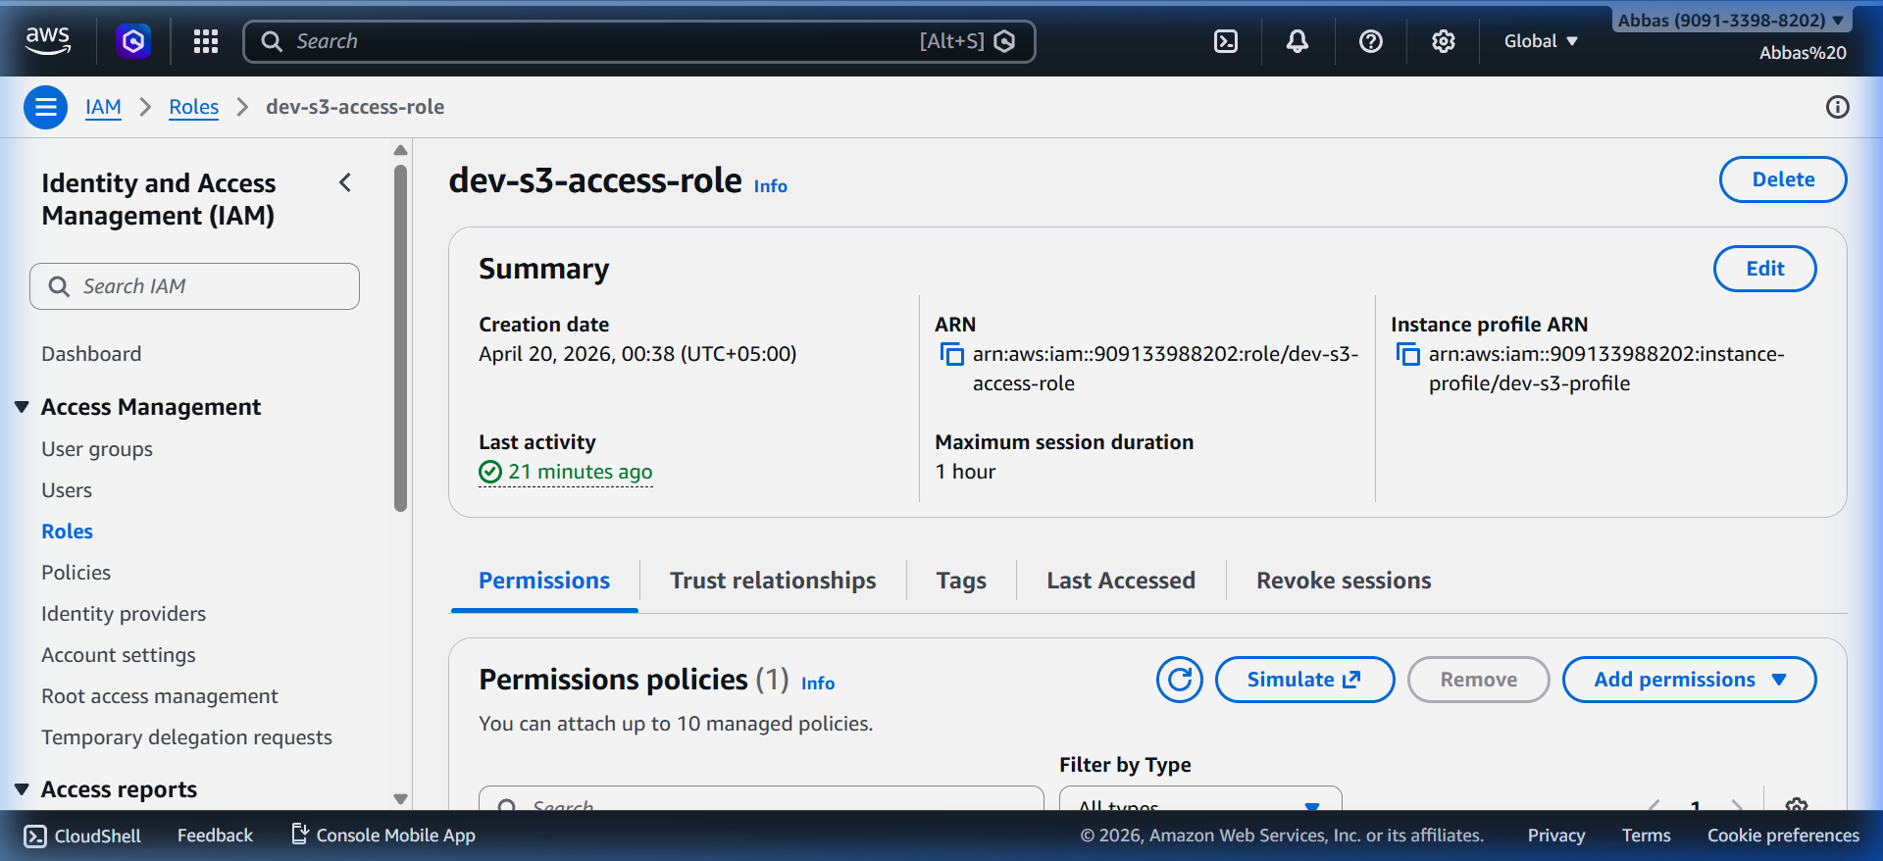
Figure 3.5: IAM Role for EC2 S3 access
[ Figure 3.6: DynamoDB table for state locking ]
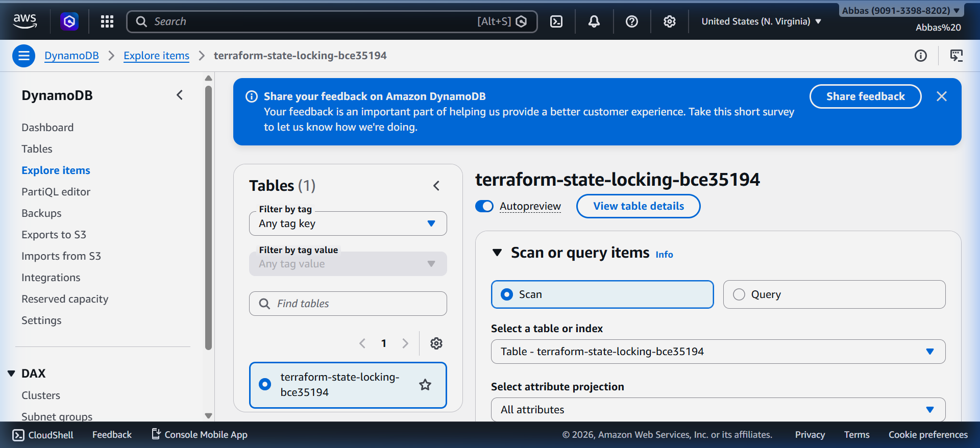
Figure 3.6: DynamoDB table for state locking
[ Figure 3.7: .tfstate file stored in S3 bucket ]

Figure 3.7: .tfstate file stored in S3 bucket

Task 4: Auto Scaling Group with CloudWatch Alarms

Launch Template
Property | Value
Template Name | dev-web-lt
AMI | Ubuntu 22.04 LTS
Instance Type | t3.micro
User Data | Installs Nginx, stress-ng, custom HTML page

Auto Scaling Group
Property | Value
ASG Name | dev-web-asg
VPC Zones | Both public subnets (us-east-1a, us-east-1b)
Minimum Size | 1
Maximum Size | 3
Desired Capacity | 1

Scaling Policies
Policy Name | Adjustment | Cooldown
Scale Out (dev-scale-out) | +1 instance | 120 seconds
Scale In (dev-scale-in) | -1 instance | 120 seconds

CloudWatch Alarms
Alarm | Metric | Threshold | Periods | Action
dev-high-cpu | CPUUtilization | >= 60% | 2 x 60s | Trigger scale-out
dev-low-cpu | CPUUtilization | <= 20% | 2 x 60s | Trigger scale-in

Stress Test Procedure
To test auto scaling, SSH into an ASG instance and artificially raise CPU:
# Step 1: SSH into an ASG instance
ssh -i dev-key.pem ubuntu@<ASG_INSTANCE_PUBLIC_IP>
# Step 2: Run stress test to raise CPU above 60%
stress-ng --cpu 4 --timeout 300s
# Step 3: Monitor CloudWatch Alarms → dev-high-cpu should enter ALARM state
# Step 4: After stopping stress, ASG scales back in to 1 instance

Screenshots - Task 4
[ Figure 4.1: Launch Template configuration in AWS Console ]
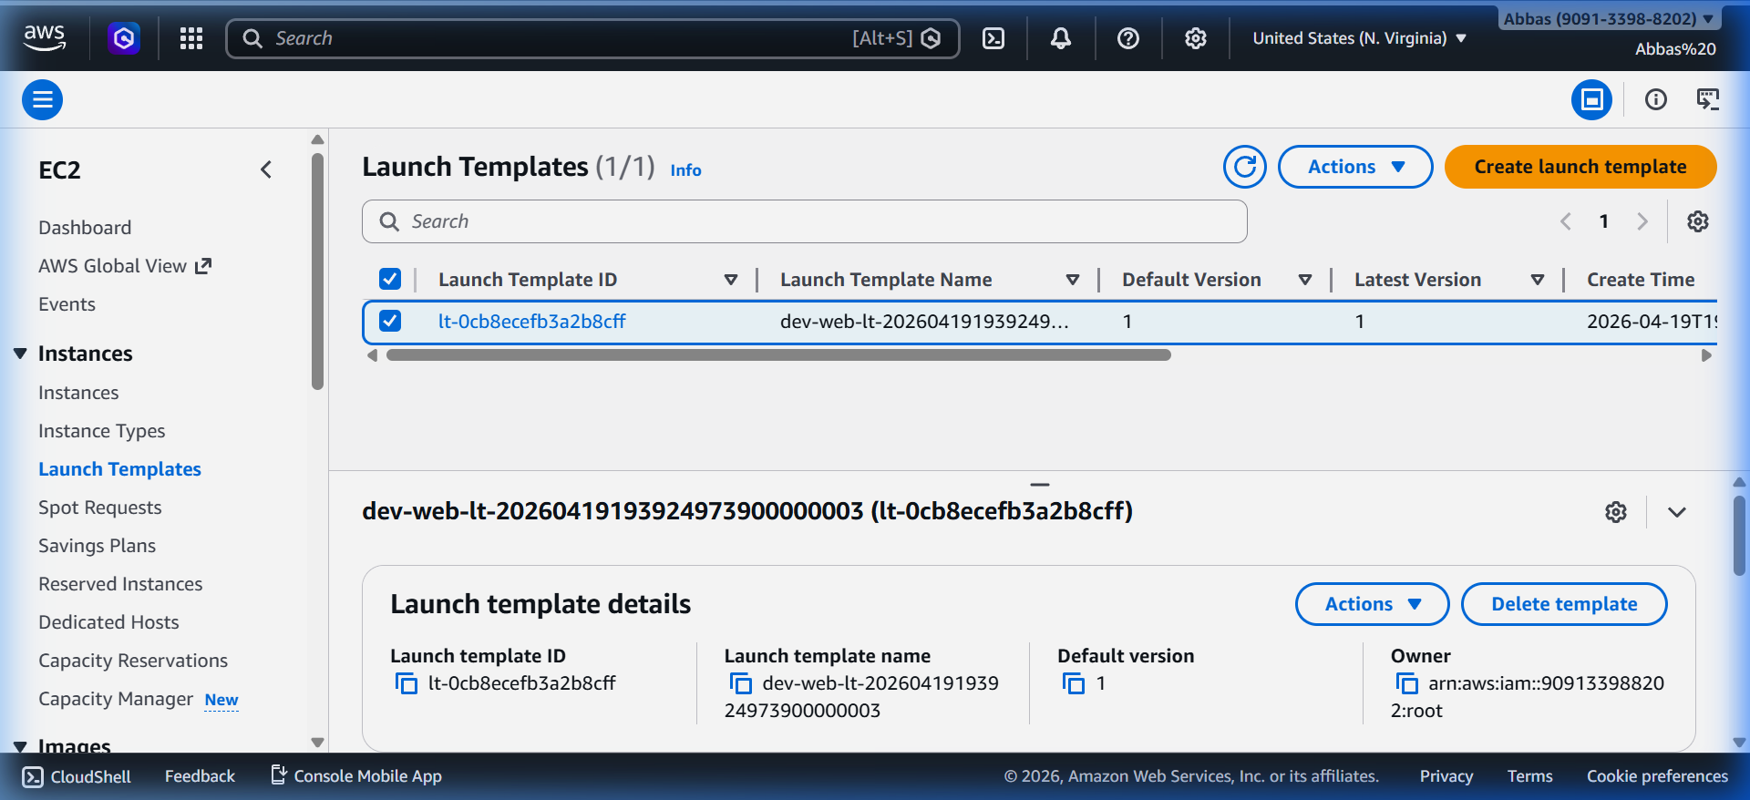
Figure 4.1: Launch Template configuration in AWS Console
[ Figure 4.2: Auto Scaling Group in AWS Console with running instances ]
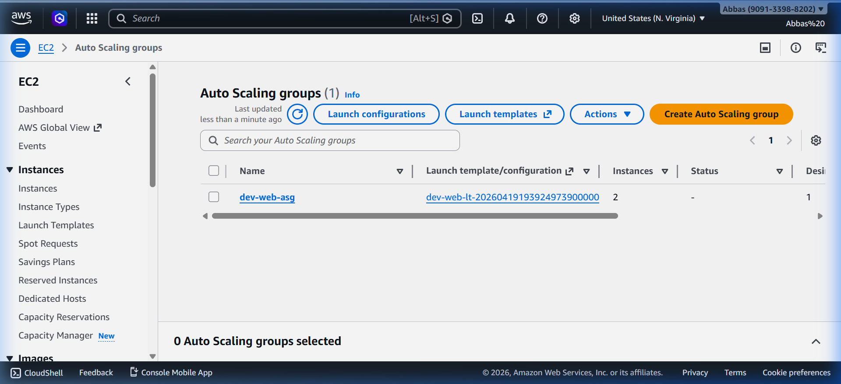

Figure 4.2: Auto Scaling Group in AWS Console with running instances
[ Figure 4.3: Scaling policies in AWS Console ]
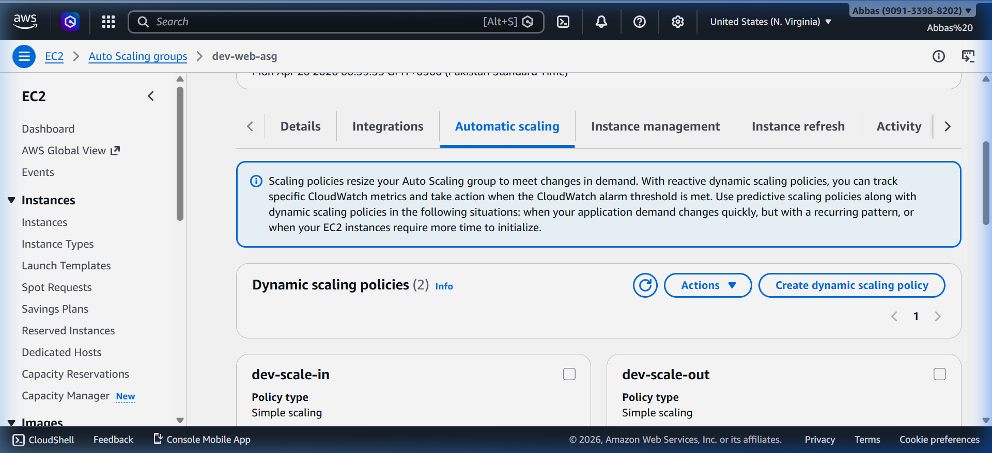
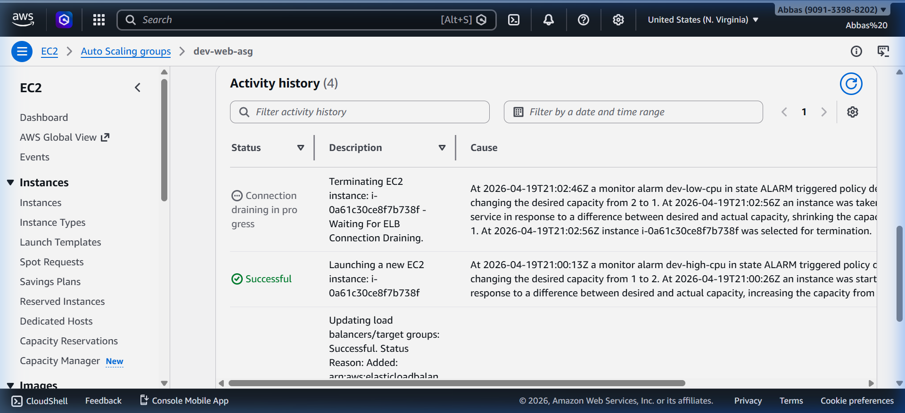
Figure 4.3: Scaling policies in AWS Console
[ Figure 4.4: CloudWatch high-cpu alarm in ALARM state ]

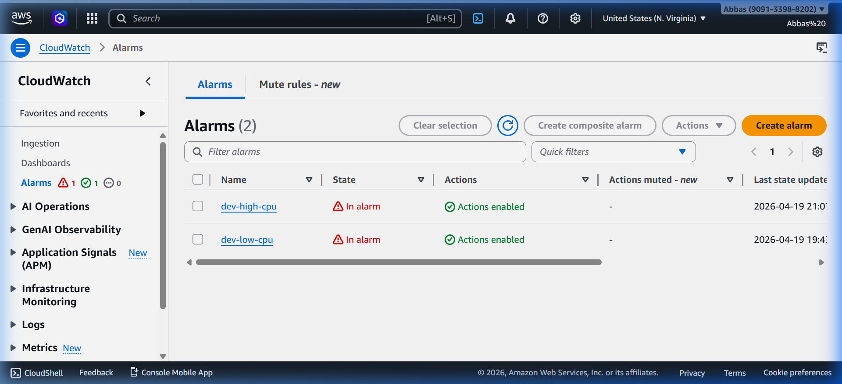
Figure 4.4: CloudWatch high-cpu alarm in ALARM state
[ Figure 4.5: Terminal showing stress-ng command running ]

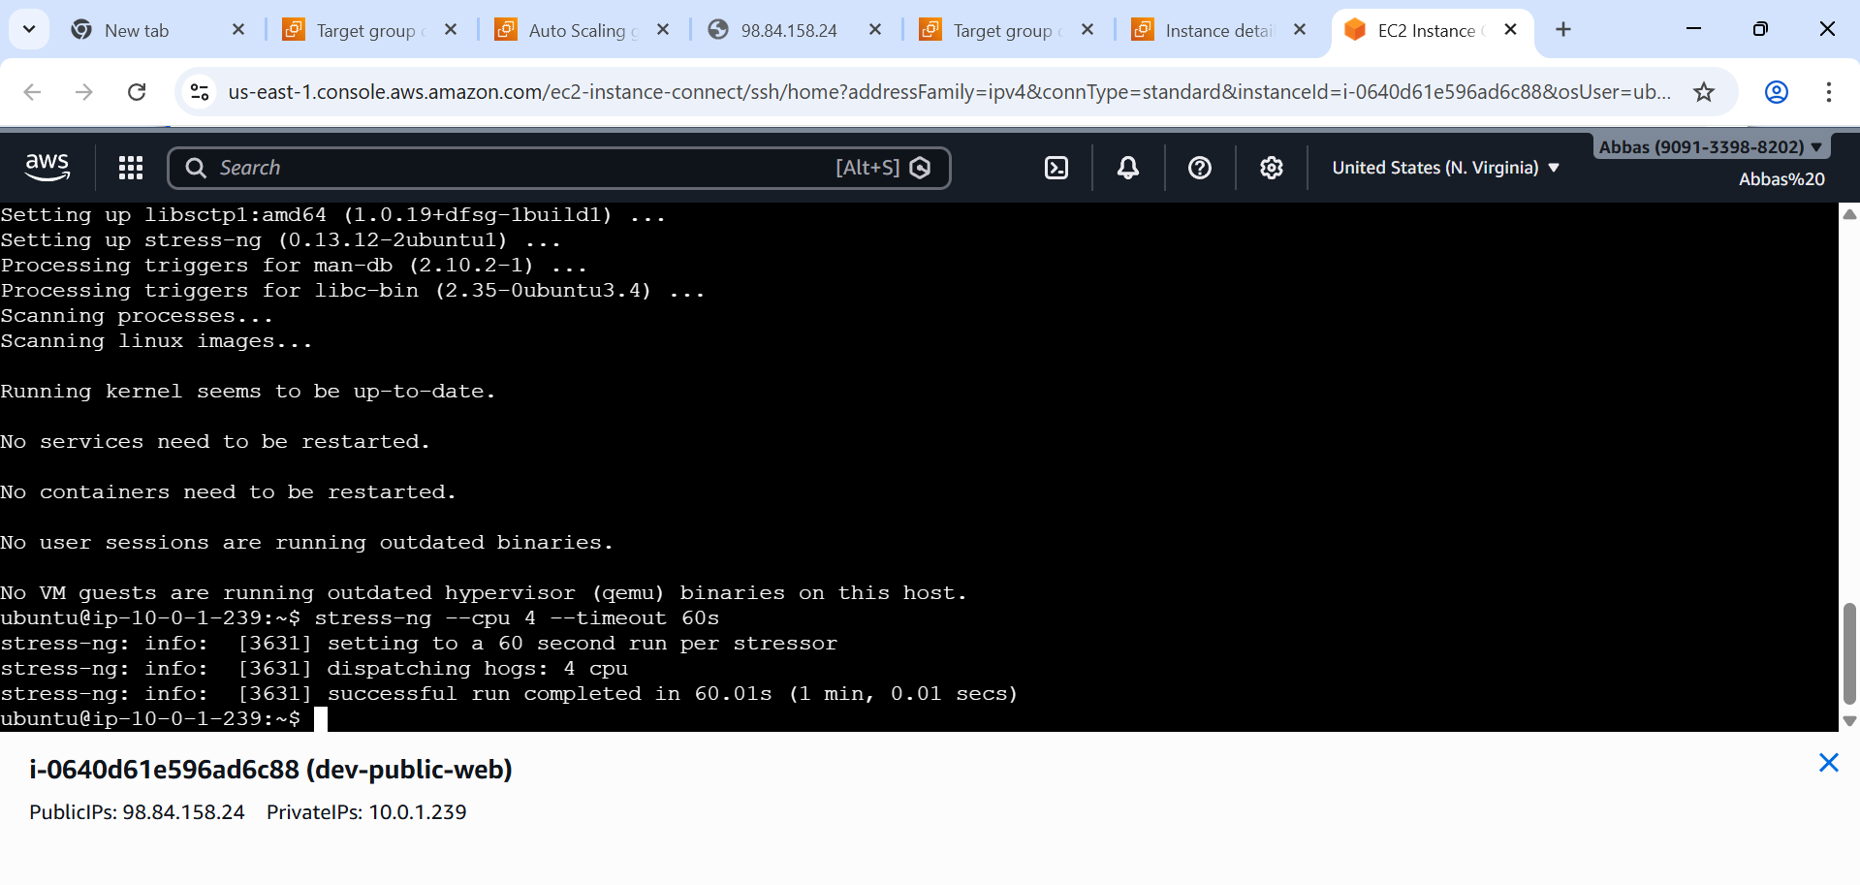

Figure 4.5: Terminal showing stress-ng command running
[ Figure 4.6: ASG Activity History showing scale-out event ]
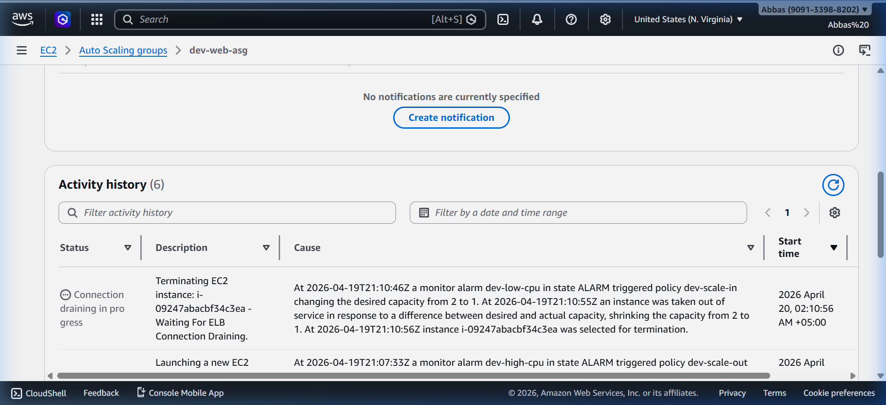
Figure 4.6: ASG Activity History showing scale-out event
[ Figure 4.7: ASG Activity History showing scale-in event ]
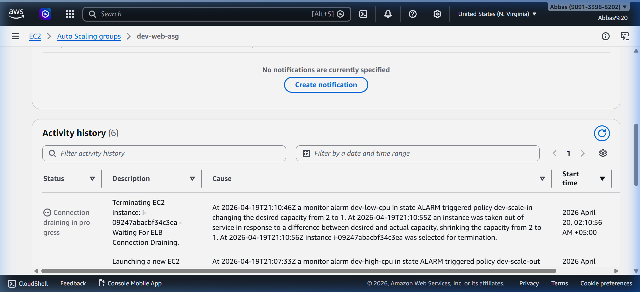
Figure 4.7: ASG Activity History showing scale-in event

Task 5: Elastic Load Balancer with Health Checks

Application Load Balancer
Property | Value
ALB Name | dev-alb
Type | Application (Layer 7)
Scheme | Internet-facing
Subnets | Both public subnets
Security Group | dev-alb-sg
DNS Name | dev-alb-818828936.us-east-1.elb.amazonaws.com

Target Group
Property | Value
Name | dev-web-tg
Protocol | HTTP
Port | 80
Target Type | Instance

Health Check Configuration
Setting | Value
Protocol | HTTP
Path | /
Healthy Threshold | 2 consecutive checks
Unhealthy Threshold | 3 consecutive checks
Timeout | 5 seconds
Interval | 30 seconds
Success Codes | 200

EC2 HTTP Restriction
📌 Note: HTTP traffic (port 80) on EC2 instances is ONLY allowed from the ALB Security Group — NOT from 0.0.0.0/0. This ensures all web traffic routes through the ALB.

Load Balancing Demonstration
To demonstrate load distribution across instances:
# Scale ASG to 2 instances
terraform apply -var="asg_desired_capacity=2"
# Access ALB URL multiple times
curl http://dev-alb-818828936.us-east-1.elb.amazonaws.com
# Expected output alternates between instances:
# Request 1 → Instance ID: i-0abc...
# Request 2 → Instance ID: i-0def...

Screenshots - Task 5
[ Figure 5.1: ALB in AWS Console ]
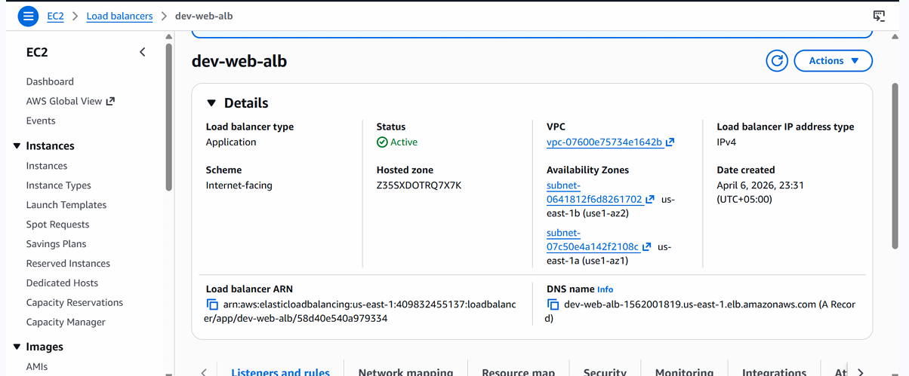

Figure 5.1: ALB in AWS Console
[ Figure 5.2: ALB DNS name tested in browser ]
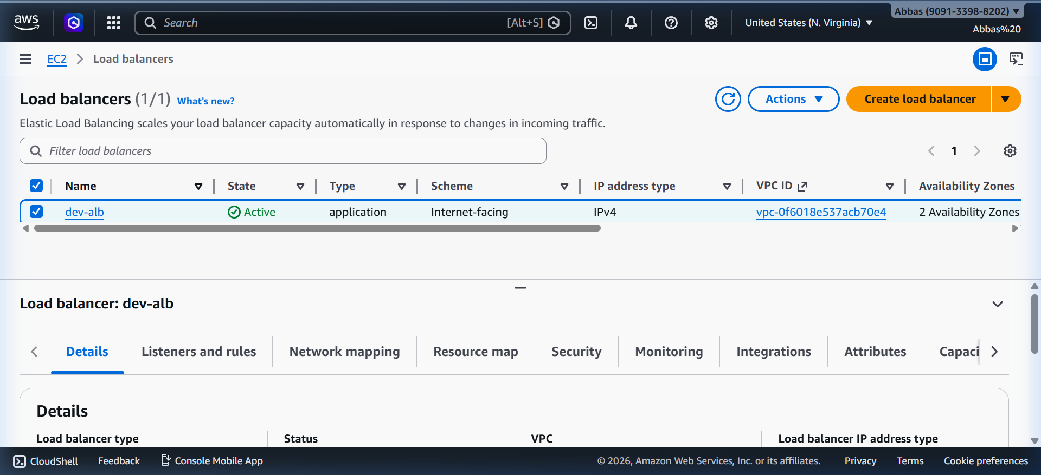
Figure 5.2: ALB DNS name tested in browser
[ Figure 5.3: Target Group with health check status ]
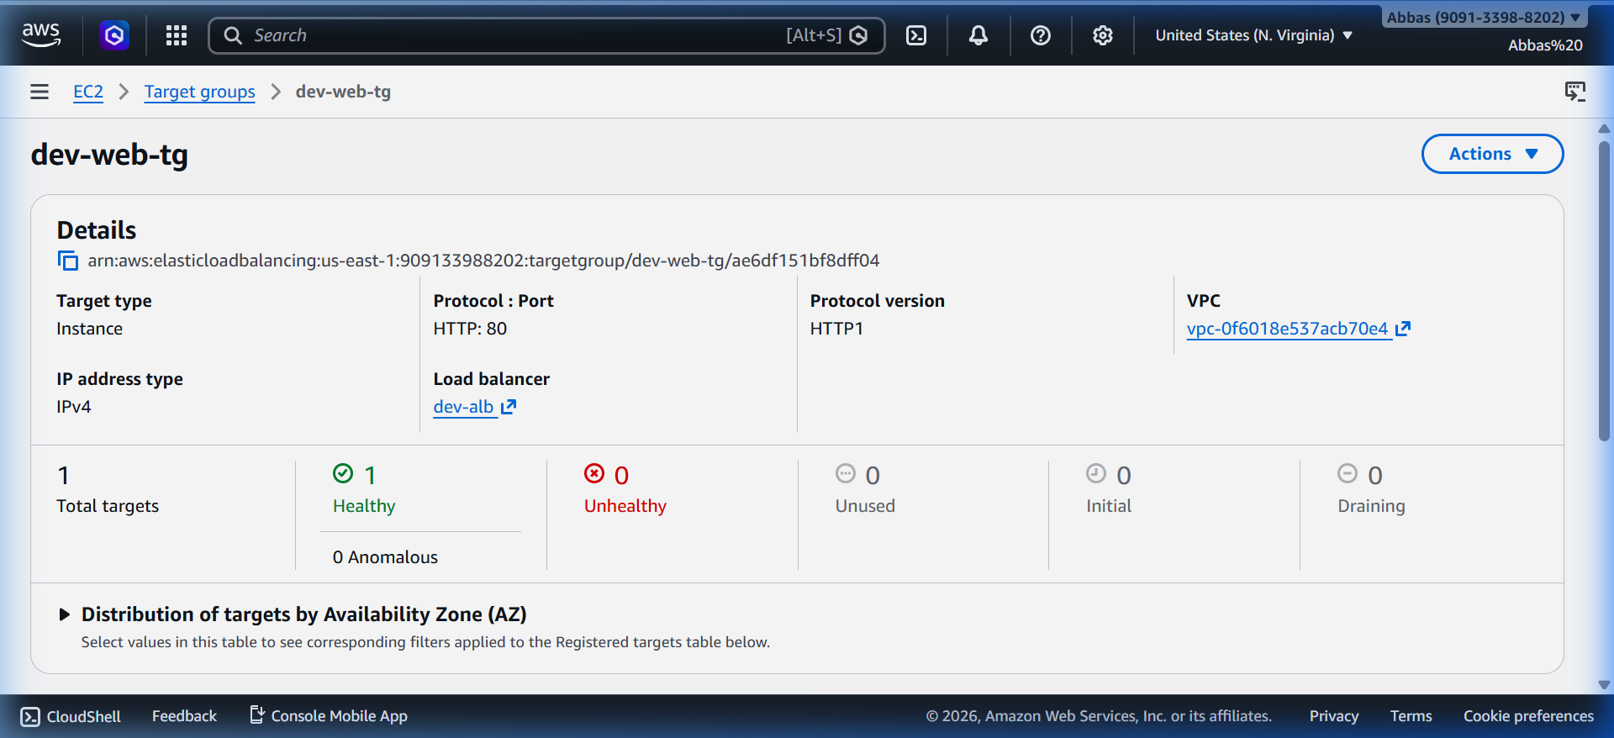

Figure 5.3: Target Group with health check status
[ Figure 5.4: ALB distributing traffic to different instances ]
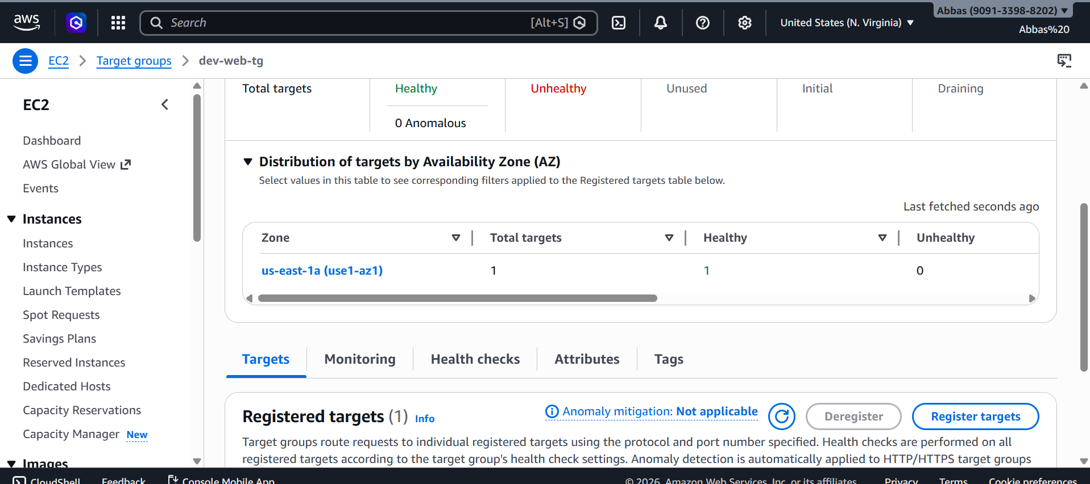
Figure 5.5: ALB distributing traffic to different instances

Task 6: Code Reusability with Terraform Modules and Packer

Project Structure
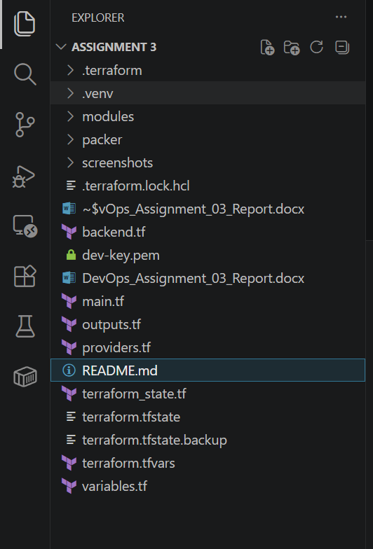

Module Inputs and Outputs
Module | Key Inputs | Key Outputs
vpc | vpc_cidr, public_subnet_cidrs, private_subnet_cidrs, environment | vpc_id, public_subnet_ids, private_subnet_ids, nat_gateway_id
security | vpc_id, environment, my_ip | web_sg_id, db_sg_id, alb_sg_id
compute | ami_id, instance_type, subnet_ids, sg_ids, key_name | public_instance_ip, asg_name, private_key_pem
alb | vpc_id, public_subnet_ids, alb_sg_id, asg_name | alb_dns_name, target_group_arn

Cross-Module References - main.tf
The root main.tf ties all modules together using cross-module references:
module "vpc" {
source = "./modules/vpc"
vpc_cidr = var.vpc_cidr
public_subnet_cidrs = var.public_subnet_cidrs
private_subnet_cidrs = var.private_subnet_cidrs
environment = var.environment
}
module "security" {
source = "./modules/security"
vpc_id = module.vpc.vpc_id # ← Cross-module reference
environment = var.environment
my_ip = var.my_ip
}
module "compute" {
source = "./modules/compute"
ami_id = var.ami_id
instance_type = var.instance_type
public_subnet_ids = module.vpc.public_subnet_ids # ← Cross-module
private_subnet_ids = module.vpc.private_subnet_ids # ← Cross-module
web_sg_id = module.security.web_sg_id # ← Cross-module
db_sg_id = module.security.db_sg_id # ← Cross-module
key_name = var.key_name
environment = var.environment
s3_bucket_arn = aws_s3_bucket.terraform_state.arn
}
module "alb" {
source = "./modules/alb"
vpc_id = module.vpc.vpc_id # ← Cross-module
public_subnet_ids = module.vpc.public_subnet_ids # ← Cross-module
alb_sg_id = module.security.alb_sg_id # ← Cross-module
environment = var.environment
asg_name = module.compute.asg_name # ← Cross-module
}

Packer Template
The Packer HCL template builds a custom AMI with Nginx, curl, and stress-ng pre-installed:
source "amazon-ebs" "ubuntu" {
ami_name = "custom-nginx-ami-{{timestamp}}"
instance_type = "t3.micro"
region = "us-east-1"
source_ami_filter {
filters = {
name = "ubuntu/images/hvm-ssd/ubuntu-jammy-22.04-amd64-server-*"
root-device-type = "ebs"
virtualization-type = "hvm"
}
most_recent = true
owners = ["099720109477"]
}
ssh_username = "ubuntu"
}
build {
sources = ["source.amazon-ebs.ubuntu"]
provisioner "shell" {
inline = [
"sudo apt-get update",
"sudo apt-get install -y nginx curl stress-ng",
"echo '<h1>Welcome to Custom AMI via Packer!</h1>' | sudo tee /var/www/html/index.html",
"sudo systemctl enable nginx"
]
}
}

Screenshots - Task 6
[ Figure 6.1: terraform plan showing modules being used ]
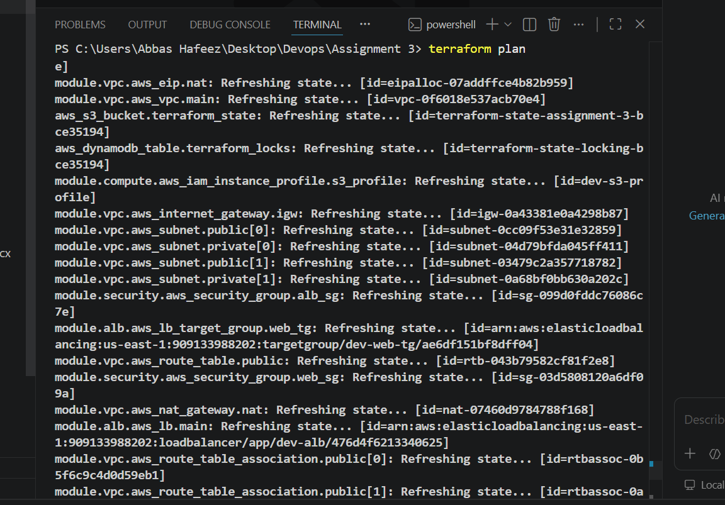
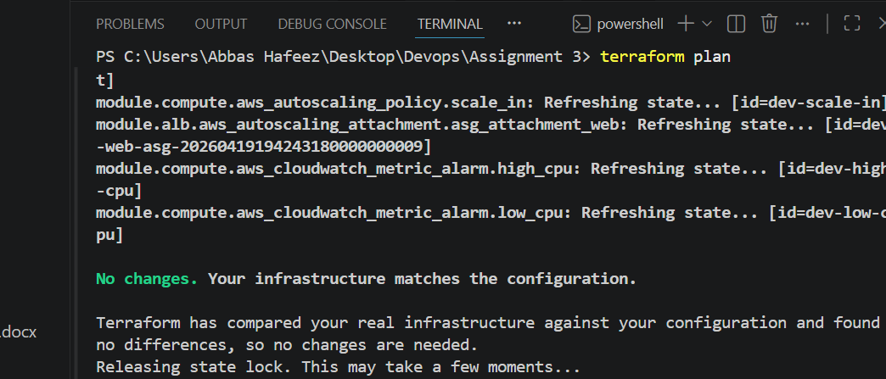
Figure 6.2: terraform plan showing modules being used
[ Figure 6.2: Packer build output ]
packer init packer/build.pkr.hcl
packer build packer/build.pkr.hcl
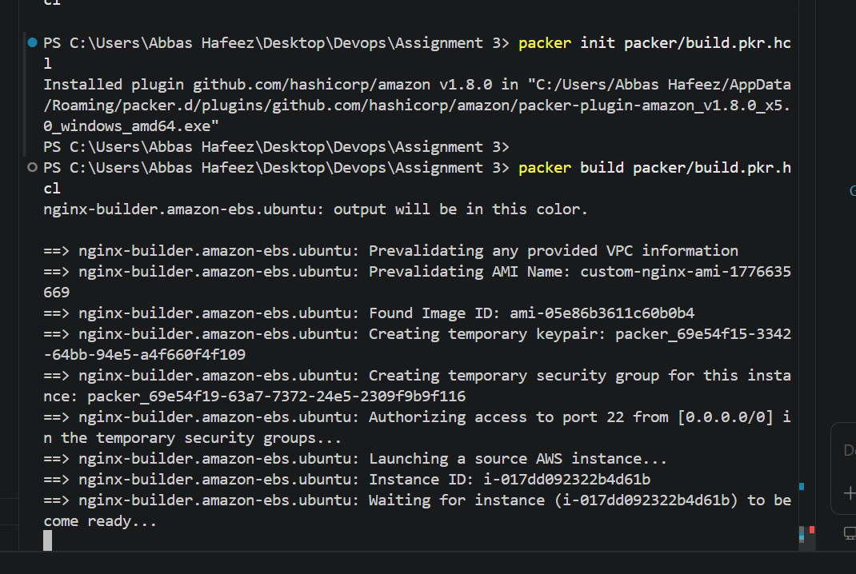
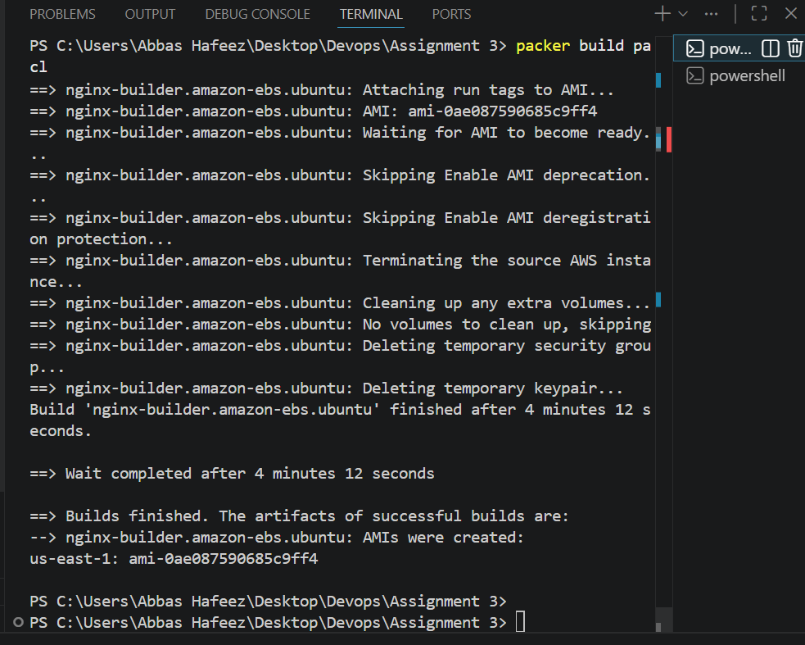
Figure 6.2: Packer build output
[ Figure 6.3: Custom AMI in EC2 > AMIs Console ]
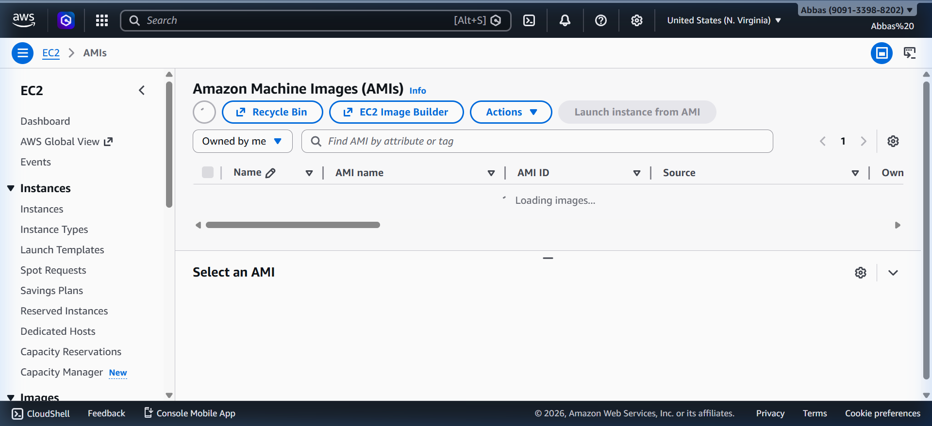
Figure 6.3: Custom AMI in EC2 > AMIs Console

Complete Terraform State List
Total Resources: 41 resources managed by Terraform across 6 tasks.
# | Resource
1 | aws_dynamodb_table.terraform_locks
2 | aws_s3_bucket.terraform_state
3 | aws_s3_bucket_public_access_block.state_block_public
4 | aws_s3_bucket_server_side_encryption_configuration.state_encryption
5 | aws_s3_bucket_versioning.state_versioning
6 | random_id.bucket_suffix
7 | module.alb.aws_autoscaling_attachment.asg_attachment_web
8 | module.alb.aws_lb.main
9 | module.alb.aws_lb_listener.web_listener
10 | module.alb.aws_lb_target_group.web_tg
11 | module.compute.aws_autoscaling_group.web_asg
12 | module.compute.aws_autoscaling_policy.scale_in
13 | module.compute.aws_autoscaling_policy.scale_out
14 | module.compute.aws_cloudwatch_metric_alarm.high_cpu
15 | module.compute.aws_cloudwatch_metric_alarm.low_cpu
16 | module.compute.aws_iam_instance_profile.s3_profile
17 | module.compute.aws_iam_policy.s3_access_policy
18 | module.compute.aws_iam_role.s3_access_role
19 | module.compute.aws_iam_role_policy_attachment.s3_attach
20 | module.compute.aws_instance.db_private
21 | module.compute.aws_instance.web_public
22 | module.compute.aws_key_pair.main
23 | module.compute.aws_launch_template.web_lt
24 | module.compute.tls_private_key.main
25 | module.security.aws_security_group.alb_sg
26 | module.security.aws_security_group.db_sg
27 | module.security.aws_security_group.web_sg
28 | module.vpc.aws_eip.nat
29 | module.vpc.aws_internet_gateway.igw
30 | module.vpc.aws_nat_gateway.nat
31 | module.vpc.aws_route_table.private
32 | module.vpc.aws_route_table.public
33 | module.vpc.aws_route_table_association.private[0]
34 | module.vpc.aws_route_table_association.private[1]
35 | module.vpc.aws_route_table_association.public[0]
36 | module.vpc.aws_route_table_association.public[1]
37 | module.vpc.aws_subnet.private[0]
38 | module.vpc.aws_subnet.private[1]
39 | module.vpc.aws_subnet.public[0]
40 | module.vpc.aws_subnet.public[1]
41 | module.vpc.aws_vpc.main

Terraform Commands Reference
# Initialize Terraform
terraform init
# Preview changes
terraform plan
# Apply changes
terraform apply
# Show all outputs
terraform output
# List all managed resources
terraform state list
# Destroy all resources
terraform destroy
# Test variable validation (should fail)
terraform plan -var="instance_type=t2.micro"
# Scale ASG manually
terraform apply -var="asg_desired_capacity=2"
# Migrate state to S3 backend
terraform init -migrate-state

Conclusion
This assignment successfully demonstrates the provisioning of a complete, production-grade AWS infrastructure using Terraform with Infrastructure as Code (IaC) principles. All 6 tasks were completed with proper implementation following AWS and Terraform best practices.
Skill Demonstrated | Implementation
Infrastructure as Code (IaC) | Full Terraform automation — zero manual AWS Console steps
AWS Networking | VPC, public/private subnets, IGW, NAT Gateway, route tables
Security Best Practices | Least-privilege security groups, private DB subnet isolation
High Availability | Multi-AZ deployment with Auto Scaling Group and ALB
Auto-Scaling | CloudWatch CPU alarms trigger dynamic scale-out and scale-in
State Management | S3 remote backend + DynamoDB locking for team collaboration
Code Organization | Modular Terraform structure (vpc, security, compute, alb modules)
Custom AMI | Packer template for pre-baked Ubuntu + Nginx AMI

